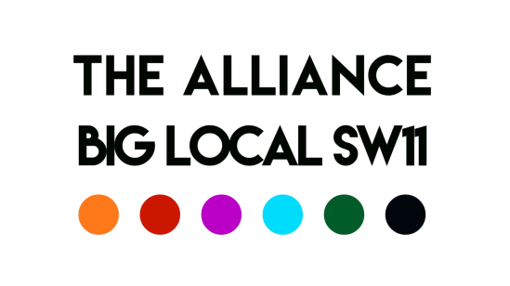

Meeting of the 4th June 2020

Chair: Delrita Note taker: Delrita
Present: Aaron, George, Del, Charlie, David, Syeda
Item | Action/Updates | Lead
- Matters arising | Syeda would like to comment that she is happy to continue providing meals to the residents at the sheltered housing and thinks that instead of duplicating work that St. Peters should reach out to another of the sites so that there is greater reach
- Individual Updates | Syeda – Will update the group further on the BLSW11 Alliance Covid-19 Fund following the information going to the PCC. She will send the information to Robert for it then to go to the rest of the Alliance.  Aaron – Continuing to work with groups this week, but has noticed the sense of anger and unrest. KLS is focusing on what might be needed in 2, 3, 5 years time to address the issues around poverty and mental health and the needs of the community  Charlie – Things at St. Peters are ticking along with the much reduced staff team. Some mental health issues are arising that they are dealing with. They are investigating the possibility of opening a food bank.  George – Busy at Carney’s. Staff are slowly coming back from being furloughed to work on their outreach programme. They are looking to have a mental health application fast tracked as they have heard from their members that the events in the US is bring about some depression. Carney’s conversations are going well and they are starting to run small boxing sessions in the park.  Delrita – The youth groups have received a grant to fund their year 11 project. | Syeda to send fund update to Robert
- BLSW11 Alliance Covid-19 Fund | Syeda – One application will be look at on Tuesday. Further updates will come as written above.
- & 5 Recruitment for BYV and Volunteer coordinator | Robert and Aaron will meet early next week to finalise the volunteer coordinator position.  Discussed places to advertise: CharityJobs, London Youth, our networks, linkedin, youth work websites etc.  Interviews: would prefer face to face but are prepared for either face to face or virtual.  Recruitment timeline:  Posts to be advertised: 12th June  Closing date: 13th July 9am  Shortlisting: By 16th July  Invitations for interview to be sent out: 16th July  Round 1 Interview dates: 20th or 22nd July  Round 2 Interview dates: 27th July  References to be checked following the interview | Aaron and Robert to meet re: Volunteer post  Aaron to ensure Syeda received communication  Aaron to share reference form with group
- Yes + verbal update | Esther will update at the next meeting | Esther to update
- Research into the impact of Covid-19 on the Sector | David will be working with the JV on finding out the impact. He has also spoken to Integrate Agency regarding the Lambeth survey. Aaron suggested getting in contact with Julie Bristow at Wandsworth Care Alliance.  Lots of the data gathering charities are pooling data together regarding the sector would be useful to keep an eye on that progress. | David to contact Julie  Aaron send link to David regarding data
- August ‘Celebrate Battersea’ event | Group felt that it would be a good idea for a celebration event. This needs to have more thought in a separate meeting. Syeda suggested working with the Festive Committee.  Aaron made the suggestion that it would also be good to arrange a Battersea wide meeting to see how organisations are coping during these times. | David arrange a separate meeting for this event.  David contact the festival committee  Aaron to investigate meeting
- Joint working/projects | Delrita mentioned the joint funding bid that was successful for the year 11 project.  George worked with Providence House to get a family mediator to work with a young person.  Aaron – Paula has joined as the Head of the Love to Learn education team and will be arranging meetings with us.
- AOB | None
Date of Next Meeting: 18th June 2020; 10:00

