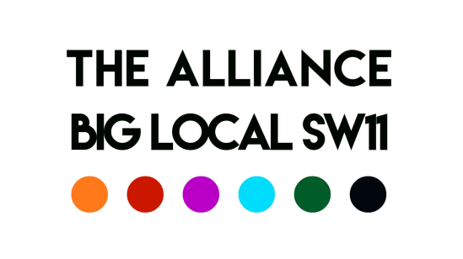

Meeting of the 30th July 2020

Present: Patrick, Robert, Aaron, Del, Esther, Syeda, George, David
Chair: Robert Minute taker: (David)

- Catch-up

Patrick – Worker back from furlough; children’s services developed online; plan to open in September

Del – Summer provision underway but still uncertain about Council’s position; Battersea Summer Scheme underway

Aaron – full summer programme underway, 2 activities a day for five weeks;

Esther – 4 sessions a week using PH, parks, open spaces; film making project underway

George – active every day; no capacity to take on unknown referrals

- Recruitment

- BYV – over 100 applications, 8 shortlisted, 4 through to second round, final selection by Youth Panel, post offered pending references

- Volunteers Coordinator – 68 applications, 6 shortlisted, 5 interviewed; 2nd round interviews between 2 candidates; post offered subject to references.

- Finances: BLSW11 payment in 2 phases £12.5k September and December. JV payments quarterly but £40k available from August

- Budgets for BYV and Volunteer Coordinator projects of (say) £5k each needed to be secured and confirmed from arrangements with JV and/or negotiation with LB Wandsworth; Action: Aaron and David to manage and report back

- Action: It was agreed that the Alliance would arrange for the BYV and Volunteer Coordination workers to meet with BLSW11 members and partners

- Joint Work

- Intensive joint working over BYV and volunteer coordinator recruitment

- Esther/Del/George working on summer programme

- Esther/Del working on Lottery bid

- Esther/Del/George working on Battersea Youth project

- Providence/Carney’s coordinated response to recent Banana Park incident

- Alliance (Stock Take)
Patrick asked about the main objectives that the Alliance had set itself.
This led to a discussion on how the Alliance has been working together, what has been achieved and what might be achieved going forward:
Positive endorsements of the Alliance’s approach (George “the Alliance’s collaboration has been excellent; we are able to open doors and access resources that might not otherwise have been available.”).
Discussion reaffirmed the Alliance’s commitment to “rebuilding the social fabric of Battersea (Aaron) (Alliance Strategic Objective) by focussing on Isolation, Loneliness, Mental Health and Employment (Esther) (BLSW11 and Alliance Strategic Objectives).

By working in Partnership the Alliance and BLSW11 combine Strategy and Delivery (Robert).

In summary:
- Through the BYV and volunteer coordination recruitment experience the Alliance had been able to engage with the right agencies and focus on ensuring that priority is give to the most marginalised (Esther/George)

- This also helped us to look in detail at baseline data about youth provision that will help support future funding applications (Del)

- The collation of data and sharing of information has been invaluable (George)

- The £120k a year investment from the JV was a major achievement
By 2021 it is anticipated that:
- The volunteer coordinator will have built relationships with local organisations; providing skills and training

- BYV will have engaged with marginalised young people to support their gaining a voice in matters that affect them and the wider community

By the end of the BLSW11 involvement 2025/6 the aim is that:
- The voluntary community sector in Battersea will be more resilient and better resourced

- Local people will have more say

- Isolation, Loneliness and Mental Health will be significantly less of a barrier to people participating in work, volunteering and the community life of Battersea.

This summary provides a snap-shot of the Alliances’ work and ambitions; it does not give a full account of its Strategy or the many examples of joint working that have happened since its formation.

Syeda suggested that the Alliance should present this to the BLSW11 Partnership. Action

- Battersea Fights Back – approval needed from BLSW11 PC before finances can be confirmed. Action

- Digital Inclusion - Minutes of meeting called by KLS and held on the 29th July, to be circulated. Action

- AOB
- Patrick advised that St Peter’s Battersea are recruiting for Youth worker and Worship Pastor

- Aaron said that KLS were recruiting to their Elders work programme

Dates of Next Meetings (all at 10:00 am start)
13th August
7th September
8th October
12th November
10th December

