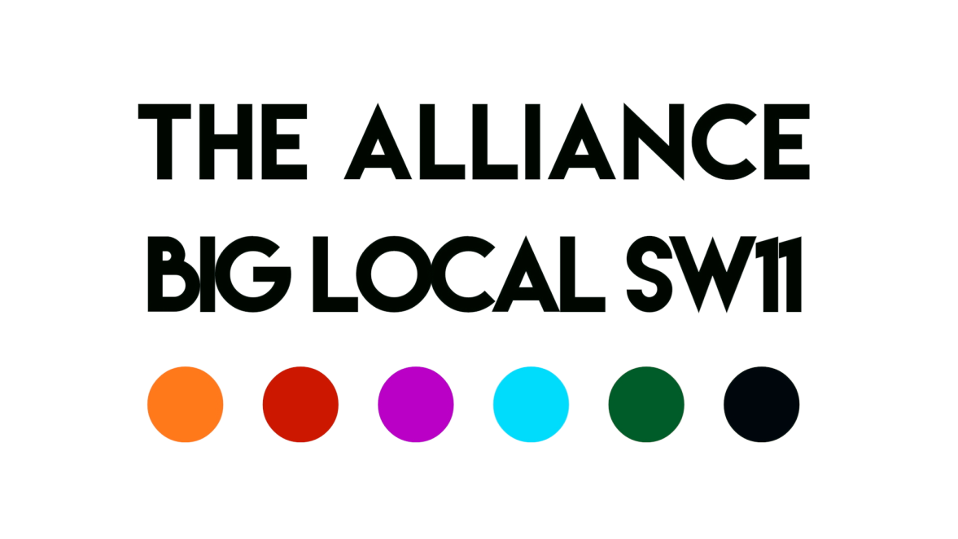

‘Battersea Volunteers’: building Battersea communities in partnership with local volunteers

21Feb20
DRAFT – NOT FOR CIRCULATION

Aaron Barbour 020 7223 3845
Director aaron@klsettlement.org.uk
Katherine Low Settlement www.klsettlement.org.uk

108 Battersea High Street
London
SW11 3HP

Katherine Low Settlement Ltd is a registered charity no 1081248 and a company limited by guarantee no. 3814833
“After working with my mentee for several months, she tells me that she enjoys maths now and she is confident. We have learned tables, time and using money which are skills for life and she would not have learned otherwise as they are not going to be repeated in school.”
Feedback from a KLS volunteer Learning Mentors who supports a local refugee young person’s education
- Summary
We ask that Big Local SW11 provides core funding of £25,000 for Battersea Volunteers. Battersea Volunteers is a key component of BLSW11’s three-year strategy, which aims to tackle Isolation, Loneliness and mental health (Depression and Anxiety) in SW11We are now ready to realise this project for the benefit of our community.
Volunteering has been widely evidenced to provide a wide range of benefits improving confidence, health, sense of purpose, community belonging, expanding social networks, gaining skills and moving towards employment. This new project is about enabling, empowering and mobilising local residents to volunteer and get more involved with the local community, mobilising local people and supporting their personal development so that they can fully participate projects and programmes that meet our (BLSW11 Alliance) strategic objectives. BLSW11’s contribution will be match funded by Winstanley & York Road Regeneration LLP. From Big Local SW11 State of the Sector report in 2018, it is estimated that:
- 1,339 people volunteer in the Big Local SW11 community
- 1,646 hours are spent volunteering each week
- £815,000 per annum is financial ‘value’ of volunteering (waged equivalent)
There are 55+ local charities and community organisation’s working in Battersea. They depend on volunteers to help provide their services and govern their organisations. To meet the growing demand for these services and make the biggest difference we can with our resources, the Alliance is seeking funding that will allow us to expand the number of people volunteering across Battersea with the support of a new post of Volunteer Co-ordinator.
We understand that local resident’s engagement and participation is a cross-cutting theme of the BLSW11 three-year plan and budget and welcome your support with this much needed work.
Note: Some of the names in the quotes and case studies have been changed to ensure confidentiality.
- An introduction to BLSW11 and the Alliance
The Alliance has been formed by the Big Local SW11 (which is an independent, resident-led group that has been awarded £1m over 10 years to invest in projects that improve opportunities for local people and strengthen our community) to help deliver its own strategy of building a stronger, more self-reliant Battersea. Visit: www.biglocalsw11.co.uk
A partnership of five local long-standing, trusted and passionate organisations (Caius House, Carney’s Community, Katherine Low Settlement, Providence House, St Peter’s Church – see Appendix 1). We have deep community roots and social relations that span many generations. We are working together, alongside 30+ other local community delivery partners, to rebuild the social fabric of Battersea.
Note: The Alliance has a 7-year strategy that accompanies this proposal for Battersea Volunteers.
2.a. Case Study: Building Social Capital in Battersea
Imagine Cairo who is eight. He goes to Providence House with his sister Charlene (10), as did his mother, her sister and brother, and their parents, and so on, so that Cairo is the great-grandson of one of first boys to attend. The kinship networks that belong to Cairo are part of the blood that flows through the arteries at the heart of the community of Battersea.
Over 50 years, hundreds of children directly, and several thousand people by association, have been part of one small cluster of experience that builds community. And through contact, connection and conversation, through real lived experiences, issues are addressed and problems resolved.
Imagine the many threads that weave together towards and away from Providence, multiplied many times through similar experiences from Carney’s, Caius, St Peters’ and Katherine Low Settlement, making the social fabric of Battersea, that share this in common – a safe place to be, built on trust!
The Alliance’ members have recognised that they could work much more closely together and have identified a further 50+ local Battersea based charities and community groups that they could work with too. Think what more can be achieved if we work better together.
- About Battersea and the Big Local SW11 Area
Hidden within the affluence of Wandsworth parts of Battersea are amongst the most deprived in London and the UK, with high unemployment, overcrowding, poor health and relative poverty. Latchmere and St Mary’s Park wards, where the Big Local SW11 Alliance focuses much of its work, rank in the most economically deprived 5% of the UK and over 40% of children live in a family dependent on income-related benefits.
Alongside the data on economic, social and environmental deprivation, the SW11 community has seen a significant reduction in statutory services provision designed to address these issues. Local Council budgets have on average reduced by 63% over last 10 years, which has caused a drastic reduction of local statutory services. These much-needed services are not universally reaching those that could most benefit from them in the community (low trust, narrow reach, high access thresholds, and over-stretched capacity).
The Alliance is motivated by the belief that stronger, more self-reliant communities provide answers to poverty, isolation and poor health (particularly depression and anxiety); and that building ‘social capital’ unlocks community capacity to address social and economic problems (unemployment, knife crime, low aspirations, disconnection from the community) far more effectively than ‘institutional’ or statutory approaches. This is because a strong community is built on social relations of trust and a deep knowledge of what is happening, to whom and where.
- The Alliance focus for the next 3 years
Over the next three years The Alliance plans to kick start the process of strengthening social capital, by building three components of ‘community infrastructure’ towards our longer term aim of rebuilding the social fabric of Battersea, namely:
- Battersea Youth Voice: a youth-driven education, mentoring and personal development programme
- Battersea Volunteers: volunteer coordination
- Battersea Capacity: strengthening Community & Voluntary Sector organisations
The Big Local SW11 has a volunteer engagement and development strand to its strategy, making Battersea Volunteers a cross cutting theme for The Alliance too. The following proposal focuses on creating and delivering Battersea Volunteers. Separate proposals are available for Battersea Youth Voice and Battersea Capacity strands of our work.

- What goes on? Volunteering in Battersea
“I enjoy being with the Elders, it’s such a rewarding job, taking them to chair exercises and chair dance…singing on the bus and helping out in the reception area with them. To see a smile on their faces makes my day. KLS is a friendly and caring environment.” Patsi volunteers with KLS’ Elders Team
Volunteers are the life blood of most local community organisations without whom we simply would not be able to provide the services that we do. We rely on the enthusiasm, time and skills of our volunteers. They are core to the delivery of community services and the governance of our organisations. They tell us that they find the work very rewarding, and get back as much as they give. Volunteers add loads of value to community work, enabling groups to work with more local people, stretching their resources as far as they can, and enriching the quality of their services.
The annual Community Life Survey 2018/19 found that in the UK:
- 22% of the UK population took part in formal volunteering at least once a month (c.12.3m people)
- 36% took part in formal volunteering at least once in the last year (c.20.1m people)
- People living in the least deprived areas were more likely to volunteer (44%) than those living in the most deprived areas (25%)
- Most common reasons for formal volunteering are: “The cause was really important to me” (45%); “I wanted to improve things/help people” (31%)
- Most common barriers to formal volunteering are: “I have work commitments” (49%); “I do other things in my spare time” (35%)
[Definition: Formal Volunteering is defined here as giving unpaid help through clubs or organisations.]
The mixed resourcing of paid staff and unpaid volunteers is at the heart of what makes voluntary sector services distinctive and effective. Extensive research has shown that whilst paid staff are vital to provide the consistency, stability and targeted skills necessary for a charity to function, it is through volunteers that our reach is extended and community bonds strengthened (Gaskin, 2003; Helping Out, 2008; Reichardt et al, 2008).
Maintaining this volunteer pool requires significant staff time, not only through providing support and supervision to volunteers, but also through processes of recruitment, induction, training and organising and attending volunteering events.
Evidence from the Institute of Volunteering Research has shown that as volunteer pools grow dispersed volunteer management, can blur the lines of responsibility and duplicate work (IVR, Management Matters, 2008). This duplication of work is felt particularly strongly by members of the Alliance and other local community organisations, which is in a borough that has no Volunteer Bureau and no CVS (Council for Voluntary Services), making volunteer recruitment and training an especially time heavy task.
Research also highlights that whilst volunteering is critical to the success of voluntary sector organisations, a common factor that limits organisations’ growth is lack of funding in their volunteering infrastructure (IVR, 2008 and 2011).
Case Study: Maggie, a volunteer at Providence House for 40 years
This April Maggie will mark 40 years as a volunteer at Providence. It began with a conversation at lunch with a friend, followed up by a visit to the centre. Since then she has filled almost every role in the organisation at some point, and still going strong. On the way she picked up a husband here, and raised a family – that is another kind of volunteering.

- Why do people volunteer?
“I feel that I am ‘coming home’ when I come to KLS. I have been a KLS ESOL volunteer for two years so I’m familiar now with the warm and welcoming atmosphere of the centre. Over this time I have seen how much goes on at KLS and how hard everyone works to support the wellbeing and education of the local community. I appreciate, too, how KLS has created and supports a community for volunteers.”
Liz, volunteers with KLS as an ESOL volunteer teacher
People choose to volunteer for a variety of reasons. For some it offers the chance to give something back to the community or make a difference to the people around them. For others it provides an opportunity to develop new skills or build on existing experience and knowledge. Regardless of the motivation, what unites them all is that they find it both challenging and rewarding.
For some it provides an opportunity to:
- Give something back to an organisation that has impacted on a person’s life, either directly or indirectly
- Make a difference to the lives of others
- Help others less fortunate or without a voice
- Feel valued and part of a team
- Spend quality time away from work or a busy lifestyle
- Gain confidence and self-esteem
- Using their skills and experience to help their local community

For some, volunteering can be a route to employment, or a chance to try something new which may lead to a career change, or an opportunity to use their skills and experience in a different environment e.g. employee volunteering or recently retired. From this perspective, volunteering can be a way of:
- Gaining new skills, knowledge and experience
- Developing existing skills and knowledge
- Enhancing a CV
- Improving one’s employment prospects
- Gaining an accreditation
- Using one’s professional skills and knowledge to benefit others

For others, volunteering appeals because of its social benefits. These include:
- Meeting new people and making new friends
- A chance to socialise
- Getting to know the local community

Most community organisations ask that volunteers offer a realistic time commitment and stick to it. That they can work in an anti-discriminatory way, and that they are enthusiastic, reliable and committed to their objectives and ethos. Skills and experience are very helpful, but not always necessary as training is provided. It is more important that volunteers have the potential to work creatively, sensitively and constructively with people. All volunteers require a DBS check, which groups should be paying for; and out of pocket expense (such as travel costs) should be covered too.
Volunteering, for whatever the reason, is key to the Big Local SW11 and the Alliance achieving its overarching objective of rebuilding the social fabric of Battersea. This is simply about local people getting involved with other local people and community organisations. And through this building relationships, bonds and social capital within our community. We must encourage and support it for Battersea to bloom.

- Battersea Volunteers – The Programme
“I felt like coming to Carney’s was a fresh start and that I had found something that suited me – I am very active and I needed something that interested me. When I started volunteering the love I felt from the kids was the first time I had felt anything like that in a long time. I felt the sense of responsibility I had to the children. All George’s promises were kept and so I became loyal. It was such a different experience to my previous job as doing pizza delivery.” Andrew, progressed from being a member to a successful Carney’s volunteer
Volunteers are already embedded as a vital and central part of the work we all do in Battersea. But we also know that there is much scope and enthusiasm amongst the local community to get involved and volunteer. This will enable our collective services to grow and create the positive connections between people that make communities thrive.
A Volunteer Co-ordinator would be at the heart of this:
- Enabling community organisations to expand the number of people volunteering in Battersea over the next three years (ensuring they have a good experience volunteering), which in turn will increase frontline service capacity.
- Building Community organisation’s skills, capacity and standards to support more volunteers.
- Recognising and celebrating the importance of volunteers in Battersea.
- Training and personal development programmes will build local capacity to address issues that cannot be fully tackled by the statutory sector
- Directing volunteers towards projects and programmes that address BLSW11 priorities
To establish and grow Battersea Volunteers we envisage that there will be 4 stages.
Stage 1: Building relationships & fact finding
A new Volunteer Co-ordinator would start with a ‘Volunteer Needs Assessment’ to:
- Map existing volunteering in the patch.
- Build a picture of assets and concerns of community organisations in relation to how they work with volunteers (e.g. recruitment, training, supervision, retention).
- Build relationships and networks with local community partners – the foundation for success of all future work.
To do this they would conduct research:
- Desk research: key word searches of community and academic research in the UK and abroad into volunteering in local communities: to understand best practice, what works and what doesn’t, systems, tools and training. Learning from others about practices that we can apply in Battersea.
- Data Collection: Develop a short online questionnaire (using survey monkey) about volunteering in Battersea that will be sent to community organisations in the patch. The information gathered from this will inform and help us conduct 25-30 semi-structured face-to-face and telephone interviews, over 3-4 months, with local charities and community groups and their volunteers. This will help us understand how (HR practices, systems and record keeping) and why they work with volunteers. We will ask them to focus on assets and concerns (perception of needs and attitudes), awareness of existing volunteer support services and ideas for new support services/projects. We will reach these organisations using BLSW11 directory of local organisations, as well as the networks of the Alliance partners.
- Analysis: 3-4 weeks of participative analysis and report writing (analysis will examine community, institutional and policy issues for Battersea). Including meta issues deriving from the interviews and a detailed key word analysis of the questionnaires and interviews. Followed by a discussion group with the Alliance and interested local organisations to prioritise the findings.
- Report: A written report will include findings, case studies, photos, recommendations and a plan for the way forward.
- Publish: This report will be a useful community asset that we would share widely with local partners and funders via the Alliance, BLSW11 and other local networks, social media, download .pdf report from our website, feature in local press, share at network meetings with partners.
- Repeat Annually: Conduct an annual Volunteer Survey to ‘check in’ with local organisations and keep our ‘finger on the pulse’, understand changing community needs, and gather feedback about the quality of volunteering in Battersea (looking at volunteer satisfaction, motivations, interests, training needs).

Case Study: John volunteers at Providence House
His is a story from boy to man. Hardly chatted to anyone, hardly went to school, hardly went anywhere. For him it began with volunteering to go on our farm residentials. Then it grew to coming along for jobs where we needed an extra hand. Since then he has become our go to person when we set up any event. Volunteering with us has literally changed his life.
Stage 2: Building skills and capacity of community organisations to work with more volunteers
“We focused on developing Zion’s leadership skills and made him a Carney’s ‘Young Leader’ which involved him setting up some of our trips and activities, whilst also volunteering in the boxing sessions. He took his leadership role seriously, and had a natural talent in making people feel at ease and welcome, no matter what their background.” Zion, a leader volunteer at Carney’s Community
The research will give us the understanding we need about where community organisations are at with their volunteers, the skills and capacity they have to recruit and support volunteers, their systems and processes, and their gaps/needs.
From this we can develop a training and resources programme for organisations to attend (e.g. workshops, half/full day training, peer-to-peer learning workshops, case studies, best practice, Action Learning Sets and more) and/or a bespoke one-to-one pro bono consultancy service. This will develop their skills, systems and capacity to be able to work better with their existing volunteers as well as take on new ones. We would also look to develop a self-assessment toolkit for organisations to understand their current situation with volunteers and what they need to improve.
The Volunteer Coordinator would develop standardised templates, forms and admin systems e.g. role descriptions, application forms, volunteer policy, expenses forms, monitoring forms etc., as well as recruitment - screening and selection processes, to inductions, retention and exit procedures, that local organisations could use to streamline and/or improve their existing work with volunteers. This will raise standards and improve the volunteer experience. It will generate a standardised approach to data collection in Battersea and help us develop a better picture of what’s going on. This will be helpful as we monitor the outcomes and impact of the Battersea Volunteers programme.
Stage 3: Developing a volunteer brokerage
We anticipate that there will be a need for a volunteer brokerage – a vehicle to recruit and train volunteers. We will ask people during the research stage about this idea; as well as explore their use of existing national brokerages such as Do-It.org, Volunteering Matters, Reach Volunteers, Community Service Volunteers, Escape the City, Trustee Finder, City Year UK, Link UP London etc.
The volunteer brokerage would include recruitment drive events and workshops, using such techniques as speed dating, open days, recruitment fairs etc. with accompanying promotional material shared via leaflets and posters, as well as social media. It may extend to setting up an online brokerage and/or just tying in national brokerages as outlined above.

“I have found it rewarding and inspiring. It's opened my mind to the struggles of immigrant families and therefore helped me to understand better some of the current issues in society today. My mentee is bright and caring. It's been lovely to get to know her and work with her, and see her develop in terms of her education and confidence.” Feedback from a volunteer Learning Mentor
Stage 4: Celebrating volunteer
It is important that we recognise and thank the work our volunteers do in our community. As well as raise the profile of the importance of volunteering in Battersea. So through the research stage we will ask volunteers and community organisations how we should do this. Ideas include:
Informal | Formal
- Phone just to say ‘thank you’ – show them some love and appreciation!  - Give a monthly ‘award’ for their contributions  - Create a yearbook of volunteers  - If they work, send a letter to their CEO  - Give tickets to an event  - Offer a free professional development session  - Write an article about them  - Nominate them for a leadership position  - Help them network | - Volunteer Passport Scheme – a mobile record of their volunteering achievements  - Designate levels of achievement  - Celebrate volunteering anniversaries  - Produce a video of their work  - Provide incentives for volunteers (e.g. vouchers, discount cards i.e.ValueYou)  - Pay for training and development  - Host an annual ‘Battersea Thanks You’ event with the local MP and Mayor of Wandsworth  - Recognise them through certificates/badges  - Nominate them for a Wandsworth Civic Award  - Name an award for an outstanding volunteer  - Establish a group award to promote teamwork  - Help them find a job

- Monitoring Framework: Outputs and Outcomes
“I love the hospitality of volunteering at St Peter’s Night Shelter and welcoming people. It’s a bit out of my comfort zone but its an easy way to serve and connect with homeless people. It feels very accessible, and you get to do it alongside buddies, really fun. And if I’ve had a full on day I’ll do the washing up and I don’t have to chat to anyone!” Dawn, who volunteers at St Peter’s Night Shelter for homeless people
We will use the following monitoring framework to help us measure our progress. However, until we start to engage with and develop these with local community organisations then the following are only estimates. By investing in Battersea Volunteers and other Community Infrastructure, over the long term, we foresee a range of outcomes that in combination will evidence the rebuilding of the social fabric of Battersea.
Case Study: ‘Music for the Mind’ Gigi volunteering with KLS’ Elders
We welcomed on board the very talented Gigi. She is undertaking a PhD in music and as if that doesn’t keep her busy enough, she has developed a weekly music workshop to keep our elderly members entertained. Each week she enlists the help of a fellow student to bring music to our ears. The sessions are always creative and fun with wacky combinations such as music and portrait drawing, Chinese writing and yoga or a good old fashion sing-a-long.

8.i. Volunteering Outputs
Activities / Outputs | Year 1 target | Year 2 target | Year 3 target | Total (£) | Indicators
Total volunteers in the area (existing/new) | 5% | 10% | 15% | 15% (overall) | Recruitment records
Recruitment Events Run | 1 | 2 | 2 | 5 | Service attendance registers
Volunteer Training Events Run | 2 | 3 | 4 | 9 | Staff records
Appreciation Events Run | 1 | 2 | 2 | 5 | Staff records

8.ii. Volunteering Outcomes
Activities / Outcomes | Year 1 target | Year 2 target | Year 3 target | Indicators
Volunteer Satisfaction | 70% of volunteers report high satisfaction levels | 75% of volunteers  report high satisfaction levels | 80% of volunteers  report high satisfaction levels | Volunteer annual survey
Volunteer Diversity | Baseline created for community representation in volunteer team | Baseline improved | Baseline improved | Recruitment diversity monitoring form
Volunteer Retention | Baseline created for volunteer retention | Baseline improved | Baseline improved | Volunteering records

8.iii. Overarching Outcomes
We think that Battersea Volunteers will create the overarching outcomes of greater economic value, increased reach and increased community involvement. These contribute to BLSW11 strategic aims of building stronger, more robust and skilled community organisations in Battersea so we are better placed to tackle Isolation, Loneliness and Mental Health (depression & anxiety), whilst involving and skilling up local residents to rebuild the social fabric of Battersea.
Outcome 1: Adding Economic Value
On a national level it is estimated that volunteering contributes around £22.6 billion to the annual UK economy (UK Civil Society Almanac, NCVO 2017). This calculation method (used by NCVO and Office for National Statistics) places a volunteering hour at a value at the UK median wage of £13 per hour.
This contribution is filtered through voluntary sector services like the Alliance members and its delivery partners, where they maximise the use of their resources through supporting a large number of volunteers with a smaller paid staff team.
AIM 1: Through the creation of this new post we propose to grow the volunteer pool in Battersea by 15%, as well as up-skilling and mobilising existing volunteers, over the next three years. Using the NCVO calculation method, by year three of this post the growth in our volunteer pool will result in an annual total of 1,893* volunteer hours (weekly), worth over £937,250 per year.
[*based on BLSW11 State of the Sector report figures.]
Outcome 2: Increasing Reach
The case for funding this post stretches far beyond the discrete valuing of volunteer hours. Consolidating our volunteering support within the post of Volunteer Co-ordinator would release current staff of some of their volunteer supporting functions. This release of staff time means that the added value of this post would be felt across entire organisations, enabling our staff teams to refocus their time on developing and enriching our current services whilst expanding their volunteer teams.
AIM 2: We estimate that local community services will have increased their reach to 10% more beneficiaries in Battersea over the next three years.
Outcome 3: Increasing Community Involvement and the related benefits of volunteering
Extensive studies by the Institute of Volunteering Research have demonstrated that the value of volunteering goes far beyond that of increasing the capacity of the workforce, enabling also an organisation’s connection to the communities it serves.
Volunteering has been widely evidenced to provide a wide range of benefits improving confidence, health, sense of purpose, community belonging, expanding social networks, gaining skills and moving towards employment (Cabinet Office, 2008; WRVS 2011; United Health Group, 2013; Ipsos MORI, 2015; Millennial impact Report, 2016; London School of Economics/Harvard Health, 2017).
At present many of the communities we serve are underrepresented within our volunteering workforce. We know that for older people remaining purposeful is an important aspect of maintaining health and wellbeing and also we know that for refugees building confidence, local work experience and an active CV can be vital for tackling high rates of unemployment.
AIM 3: With this post we will reshape volunteer recruitment processes across Battersea to include diversity monitoring to create a baseline figure for our current community representations. We will use this data to develop new routes of volunteer engagement and targeted support to broaden the range of people involved in the volunteering life of Battersea.
Outcome 4: Developing cross-cutting themes and strategic links
The Volunteer Coordinator will work with BLSW11 and the Alliance to ensure that our support for volunteers is developed alongside and in concert with the other main strands of our strategy – Battersea Youth Voice and working with local community and voluntary sector organisations.
We want to encourage a community development approach to volunteering that values and supports local people’s potential to contribute to building a more self-reliant and resilient community.
AIM 4: We will target 10% of existing volunteers (estimated 130 people) over three years, to support their personal development; provide training in community development, mental health and project planning.
Outcome 5: Resourcing volunteering for effective action
By 2022 we aim to be in a position where Battersea Youth Voice and our Volunteer strands of work are starting to make a significant impact in the area of Battersea, putting the community at the centre of debates about what needs to be done to tackle some of the most challenging issues in SW11.
Better youth engagement and representation plus stronger volunteer coordination will increase the community’s capacity to develop programmes that address loneliness, isolation and mental health.
AIM 5: By 2022 to have produced a cross-cutting strategy that commands the support of the wider community, statutory and private sector backed by additional resources (community investment).

- Evaluation
The scope of the project evaluation will be to determine the extent to which the Volunteer Co-ordinator has succeeded in realising the outcomes, outputs and delivery activities. A participant-orientated summative evaluation will be conducted – placing the participant and stakeholder at the heart of the evaluation. We work in a participative manner so will work with our staff and volunteers to identify appropriate indicators and then develop relevant data collection methods to assess whether the project met its outcomes, whether there were any unintended consequences, identify the learnings, and how to improve the role of the Volunteer Co-ordinator.
These include using recruitment records, diversity monitoring, annual appraisals and an annual volunteer survey to evaluate. A final report (including case studies) will be submitted upon completion.
Case Study: Tom received a ‘Wandsworth Civic Award’ for his volunteering with KLS’ older people
Before she died early this year Iris, one of KLS’ elderly members, put forward one of our long standing volunteers, Tom, for a Wandsworth Civic Award. This is what she wrote in her nomination form: “Tom is a very kind and caring person. He serves lunch at the Katherine Low settlement 2 or 3 times a week at the elder’s lunch club and helps out at special occasions too. He is always punctual. He knows each individual and treats everyone with special care. He never loses his cool, even when people can be grumpy and even rude! He always has a smile!” Tom was delighted to receive the award and took Iris along to the celebration event.
- Staff and Volunteer Team
We have an experienced and highly qualified team of staff and volunteers who will run Battersea Volunteers:
Volunteer Coordinator (to be recruited) – Battersea Volunteers will appoint a highly experienced and competent Volunteer Co-ordinator who will be able to work across the community. See Job Description (Appendix 2). After an initial scoping phase, a 1-year indicative plan will be developed, including key indicators, that will be used to track performance, successes as well as challenges.
The new Volunteer Coordinator will be based at KLS. They will be situated physically in the same room as their line manager; as well as hold formal weekly meetings (during the induction and probation period) to monitor closely the effectiveness of this new role. We expect their relationship will develop and deepen over time, but they need to create the time and space for reflective practice.
This post will be recruited online (e.g. CharityJob), via the Alliance member’s websites, social media channels and local ‘real life’ charity and community networks, as well as through local/regional youth and community networks.
Aaron Barbour, Manager – The day-to-day operations of Battersea Volunteers will be managed by Katherine Low Settlement’s CEO. Aaron has worked with UK-focused charities for more than 25+ years in a variety of roles including, most recently, as a trustee, chair of trustees, senior department head, government advisor, campaigner, consultant and CEO.
Volunteers – A small team of 3-5 volunteers may be recruited and trained to support Battersea Volunteers development, depending on what is needed.
- Ensuring Quality
To ensure quality we will manage Battersea Volunteers as follows:
- Oversight by The Alliance steering group: Made up of five CEO’s and Senior Managers from 5 well-established local Battersea charities and reps from BLSW11. They will take responsibility for strategic oversight of Battersea Volunteers. Acting as a ‘critical friend’, helping to steer, advise and guide the programme as appropriate. They already meet monthly (as we have done for more than 2 years), and are available for additional support via telephone and email.
- Performance reports to the BLSW11 Board: The Board approved The Alliance’s 7-year strategy in 2018, included in which were quarterly reporting mechanisms, a risk register, and up-to-date organisational policies, to ensure high-standards of our services, staff, volunteers and users.
- Regular self-assessment by the project team: Effective staff support and line management is key to any successful project. To this aim the project staff, volunteers and manager hold regular (weekly/monthly) project team meetings and regular individual staff supervision sessions to ensure that the programme is meeting its targets, rewarding performance, troubleshooting and measuring results.
The Alliance believes that a continuous improvement approach is essential to maintain and develop service quality. This takes the form of addressing challenges, user feedback, new research, information from training and partnership work, and celebrating successes. Staff, volunteers and our users work together to continuously learn and improve. In matters of quality, organisations cannot stand still.
- Risks & Mitigation
Risk | Mitigation | Likelihood & Impact
New project – not done before | The Alliance’s 5 charities are very experienced (300+ collective years) in setting up new projects and working with local volunteers.  KLS is a well-planned organisation. We appreciate the role will evolve over the coming 3 years. Close monitoring and evaluation will help us to reflect and analyse whether or not the role is working well and how it could be improved.  They will be line managed and supported by KLS’ CEO, who initially will hold weekly supervision meetings as they settle into the job. | Low
Recruiting the right Volunteer Coordinator will be key | The Alliance has more than 50+ staff between them, and more than 1,300 volunteers. We are experienced in recruiting, inducting and supporting new staff. We will advertise widely and have a probation period if things don’t work out. We would look to recruit someone local or who has an understanding of the local area and its needs to improve on relationship building. | Low
Full funding is not immediately available | We will aim to use the initial BLSW11/JV investment to secure match funding. | Medium
The Volunteer Coordinator is overstretched | Working with 50+ local community organisations will be a challenge. So we will have to plan and allocate their time carefully to minimise them being overstretched. | Medium

- Budget
BLSW11 has set aside £50,000 a year for the next 3 years as a Local Investment Fund. We ask BLSW11 to release £25,000 a year for 3 years.
We have recently secured match funding from Winstanley & York Road Regeneration LLP.
We are also working to secure further funding from other sources. This will enable us to grow and develop Battersea Volunteers.
See Budget attached.

- Timetable
We’d look to recruit someone to fill this new position as soon as funding was granted for a three-year period. The recruitment process usually takes 2-3 months. Within this 3-year timeframe we would expect the new staff member to strengthen the business case with evidence of success and to identify possible sources of future funding for their post to continue.
- Further information
If you would like to discuss this proposal in more detail, and see our work in action then please do get in touch with Aaron Barbour on 020 7223 2845 and aaron@klsettlement.org.uk

Appendix 1 – Who’s Who in the Big Local SW11 Alliance
The Big Local SW11 Alliance is a place-based partnership, with strong roots in the local community and over 300 years of collective experience. It includes the following Battersea community organisations:
Big Local SW11
Big Local SW11 is an independent, resident-led group that has been awarded £1m to invest in projects, over a 10-year period, that improve opportunities for local people and strengthen our community in Battersea. Visit: www.biglocalsw11.co.uk
Caius House
Caius House is a centre of excellence, founded in 1887, where the potential inherent in every young person can be unlocked. With our unique team of experienced youth workers, educators, musicians, counsellors, trained dancers and media specialists we are able to support individuals and provide targeted programmes to encourage each young person to develop their individual skills and talents. Visit: www.caiushouse.org
Carney’s Community
Carney’s Community has been using boxing and intensive mentoring since 2011 to get disadvantaged and excluded young people away from a life of crime and despair. Carney’s gives them skills, discipline and self-respect. Our aim is to reduce offending, re-offending and anti-social behaviour, whilst improving social mobility and community cohesion. Visit: www.carneyscommunity.org
Katherine Low Settlement
Katherine Low Settlement is a much-loved, busy charity that has been serving Battersea and the wider Wandsworth community since 1924. Our vision is for an inclusive society where people achieve their potential together. We foster and empower communities in our neighbourhood to reduce poverty and isolation. We run a range of our own community projects to support children, young people and families, older people and refugee communities. Each week we work with 45+ charities and community groups supporting more than 1,100 people. Visit www.klsettlement.org.uk
Providence House
Providence House Youth Club has been passionate about improving the lives and outcomes for young people Battersea and beyond. Established in 1963, we continue to provide social, recreational, sporting and outdoor residential educational activities for young people and families. Our mission is to share the Christian message of Jesus Christ and to walk with young people, families and the local community in their life journeys. We are ‘here for all’. Visit: www.providence-house.org
St. Peter’s Church
St. Peter’s is a lively, diverse and growing church family whose vision is: loving God, being family, bringing hope – in Battersea and beyond. The church has been serving the local community since 1875, and they’ve just moved into a purpose-built building where they run activities for all ages. They place a high value on participation, community and diversity. Visit: www.spb.church
Other Battersea Partners
In addition to the Alliance members we have identified more than 50 local delivery partners, who have the local knowledge, relationships of trust and community services, that will be needed to rebuild the social fabric of Battersea.

Appendix 2
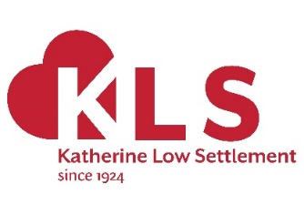
KLS’ Volunteer Co-ordinator
Job Description
Job Title: Volunteer Co-ordinator
Position: 3-year Fixed-Term Contract
Salary: £33,000 + 5% pension contribution
Hours: 35 hours /week - full time
Holidays: 25 days per year + Bank Holidays
Responsible to: KLS’ CEO
Location: 108 Battersea High Street, London SW11 3HP

About Katherine Low Settlement
Katherine Low Settlement is a charity that has been serving Battersea and the wider Wandsworth community since 1924. We are dedicated to building stronger communities and enable people to challenge and find ways out of poverty and isolation.
We run a range of our own community projects to support children, young people and their families, older people and refugee communities. We recognise there are many other expert local charities and community groups working with, for example, disabled people and mental health users. We invite them to operate from our premises – so together as partners we can meet the diverse needs of the local communities of Wandsworth. Each week we work with 45+ charities and community groups supporting more than 1,100 people. Visit: www.klsettlement.org.uk
About Big Local SW11 Alliance

The Alliance has been formed by the Big Local SW11 (which is an independent, resident-led group that has been awarded £1m over 10 years to invest in projects that improve opportunities for local people and strengthen our community) to help delivery its own strategy of building a stronger, more self-reliant Battersea. Visit: www.biglocalsw11.co.uk
A partnership of five local long-standing, trusted and passionate organisations (Caius House, Carney’s Community, Katherine Low Settlement, Providence House, St Peter’s Church – see Appendix 1) we have deep community roots and social relations that span many generations. We are working together, alongside 30+ other local community delivery partners, to rebuild the social fabric of Battersea.
About Battersea Volunteers
Volunteering has been widely evidenced to provide a wide range of benefits improving confidence, health, sense of purpose, community belonging, expanding social networks, gaining skills and moving towards employment. This new project is about enabling, empowering and mobilising local residents to volunteer and get more involved with the local community here in Battersea.
There are 55+ local charities and community organisation’s working in Battersea. They depend on volunteers to help provide their services and govern their organisations. To meet the growing demand for these services and make the biggest difference we can with our resources, the Alliance aims to expand the number of people volunteering across Battersea with the support of a new post of Volunteer Co-ordinator.
Key Objectives of the Role
- Develop and expand volunteering engagement across Battersea to assist in the pursuit of the BLSW11 Alliance’s vision, mission, values and objectives.
- Develop and implement yearly volunteering delivery plans with the Alliance; review, monitor and report on progress.
- Ensure a consistent and high standard of volunteering engagement and support across Battersea.
- Ensure effective knowledge collection and feedback systems are in place to monitor the quality and effectiveness of volunteer engagement in Battersea.

Main duties and responsibilities
- Initial research and relationship building: Conduct desk-based and qualitative research to build a comprehensive picture of volunteering in Battersea, as well as strengthening relationships with local community organisations.
- Training: Create and deliver a volunteer training programme (module based) for community organisation’s staff and volunteers, so they expand their knowledge, develop their skills and increase their capacity for working with more volunteers. You may also offer a one-to-one consultancy-type service to support individual organisations improve their volunteering.
- Recruitment: Carry out volunteer recruitment drives and events. This may lead to establishing a volunteer brokerage. Create standardised systems, process and paperwork, including implementing diversity monitoring, for community organisations to use across Battersea.
- Communication: Facilitate greater communication with and between volunteers.
- Appreciation and Thanks: Organise appreciation and networking events for volunteers; and instigate a range of informal and formal methods to thank and incentivise volunteers e.g. volunteer passport scheme that enables volunteers to gain tangible a record of their volunteering achievement to share with prospective employers.
- Monitoring/Evaluation: Launch an annual Volunteer Survey to monitor key aspects of the volunteer experience, satisfaction levels and benefits.
- Volunteering Knowledge & Reporting: Keep up to date with legislation and policy related to volunteering and make any necessary modifications to accommodate changes. Monitor and produce reports for the BLSW11 Alliance leadership team on volunteer recruitment statistics, retention rates, volunteering hours and compiled feedback from the annual Volunteer Survey.
- Budget: Manage and monitor the volunteering budget
Other duties:
- Participate in regular management supervision and annual appraisal; help to identify your own job-related development and training needs.
- Adhere to Katherine Low Settlement’s code of confidentiality, safeguarding and equal opportunities policies.
- Undertake your role in a professional manner and maintain a high-quality standard of work in accordance with aims, values and ethos of KLS.
The above job description reflects the position at the time of writing; it is not intended to be a task list but indicates the general level of work involved. It is expected that duties will be reviewed and revised as required.

Person Specification
The following skills and experience are required for this post:
Skills and Experience | Essential/ Desirable
Track record of volunteer management across a range of roles and functions. | E
Experience of developing or improving effective volunteering support and administration systems that support the whole volunteering life cycle - from recruitment to exit. | E
Ability to motivate, support and encourage volunteers and align them with the overall organisation objectives in a way that inspires them to give their best. | E
Track record of devising and delivering training on all aspects of volunteering to community organisations. | E
Experience of developing and implementing volunteer recruitment strategies, including through events, marketing materials and using social media. | E
Experience of developing new volunteering roles and initiatives. | E
Knowledge and experience with regard to safeguarding the welfare of children or vulnerable adults, ideally in volunteering contexts. | E
Experience of monitoring and evaluating projects effectively. | E
Experience of building and managing effective partnerships and external networks (that would enable you to engage in collaborative working around volunteering issues). | E
Strong communication skills (verbal and written), with excellent written and spoken English. An ability to communicate with people from a wide range of backgrounds. | E
Excellent IT skills including MS Office suite and ability to use spreadsheets, databases, social media and email. | E
Ability to work as part of a small team, listening to and valuing the contribution of all staff, service users and volunteers, whilst also working independently. | E
Committed to Big Local SW11 and the Alliances mission, vision and values. | E
Knowledge of Battersea / Wandsworth | D
Personal Qualities
Passionate about volunteering | E
A hands-on, highly motivated individual | E
Outstanding interpersonal skills, able to support volunteers with arising and sometimes personal issues | E
Trustworthy, non-judgemental, caring and compassionate, proactive, self-motivated and hardworking | E

Further Information
For further information about the post please contact Aaron Barbour, KLS’ CEO on 020 7223 2845 and aaron@klsettlement.org.uk
- Katherine Low Settlement is committed to equal opportunities.
- All offers to work at Katherine Low Settlement are subject to two satisfactory references, which is standard KLS policy applicable to all roles. KLS also ask for an enhanced DBS check.
- You will adhere to matters of confidentiality concerning this role and the KLS team.
- An induction is given to new staff, which includes sharing our policies and procedures relevant to this post.
- There is a 6-month probation period for this role.
Last updated: 10Feb20
Appendix 3: The Big Local SW11 Alliance strategy
The Alliance is a lead group of five local long-standing, trusted and passionate organisations, with deep community roots and social relations that span many generations, working together to build a stronger Battersea, that will work in partnership with other local community delivery partners.
The Alliance has already started to deliver! In 2018/19 Providence House, Caius House, St Peter’s church, Carney’s Community and Katherine Low Settlement worked together to:
- Establish a system of interagency referrals, so that young people have much more on offer than belonging to one club!
- Ran a highly successful Summer Programme
- Developed the Urban Arts Festival
- Led in the development and delivery of the first Battersea Charity Week (June 2019) – with 98 people from 61 organisations attending!
- Delivered an Intergenerational project
- Participated in the first Wandsworth Voluntary Sector Conference (May 2019)
- Met with MP Marsha De Cordova, to (amongst other things) lobby on behalf of Battersea Youth Voice.
By 2024 the Big Local SW11 Alliance will address the main priorities for Battersea by mobilising 7,000 local people and organisations in Battersea to co-produce a host of multi-facetted, creative and effective services, activities and events, including: housing, health and wellbeing, mental health, arts & culture, (un)employment, sports, advice and guidance, disability, environment, children and young people, families, elders, refugees, and more… All of which will contribute to realising our vision of rebuilding the social fabric of the community in Battersea.
Note: A copy of The Alliance’s strategy is available upon request.

Appendix 4: State of the Community Voluntary Sector in SW11
Working Across the Community Voluntary Sector in SW11
In September 2018 Big Local SW11 published its ‘The State of the Sector’ report.
The key findings were:
- Approximately 364 people work in the Community Voluntary Sector in BLSW11
- There are approximately 1,339 volunteers
- About 1,646 volunteer hours are worked each week
- Based on salaries alone the ‘value’ of the Community Voluntary Sector in BLSW11 is worth between £10-£12m per annum
- We estimate that the Sector generates £10m in turnover
- The ‘value’ of volunteering is estimated at £903,000 per annum (based on a London Living Wage equivalent value of £17,365 generated per week)
- Areas that appear to have ‘good’ coverage include: Youth, Religion, Education and Wellbeing
- Areas that appear to have ‘poor’ coverage include: Mental Health, Isolation, Environment and Poverty
Of the 55 organisations consulted during the research, 33 expressed a strong interest in working with Big Local SW11. This provides a real opportunity for any additional funds that Big Local SW11 can attract into the community to be channelled through our local organisations as ‘delivery partners’.
A key aim of our strategy is to see the development of a stronger, more vibrant and resilient community voluntary sector, that is less vulnerable to the vagaries of ad hoc occasional grants and shifts in national, regional and local policies.
Note: A copy of this report is available upon request.
Appendix 5: Big Local SW11 Area of Impact and Influence
The Big Local SW11 area consists of a group of council estates lying to the north of Clapham Junction station (covering the wards of Latchmere and part of St Mary’s Park), in the London Borough of Wandsworth. The largest is the Winstanley Estate which together with the York Road, Falcon, Kambala, Badric Court and Wayland Road estates, make up a community of around 10,000 people.
This community includes some of the most densely housed parts of Latchmere and parts of the population that are amongst the most ‘deprived’ in the Borough (and London).
While Big Local SW11 is primarily focused on delivering benefits for residents of its eligible area, we recognise that many services and opportunities for local people may lie outside the physical ‘zone’ of the BLSW11 area. From our experience Battersea resonates with younger people as their connections/points of engagement, meeting places and safe spaces covering the whole of Battersea.
The Alliance aims to engage with and deliver services across Battersea.
The map below shows for the full extent of the Big Local SW11 geographic area.
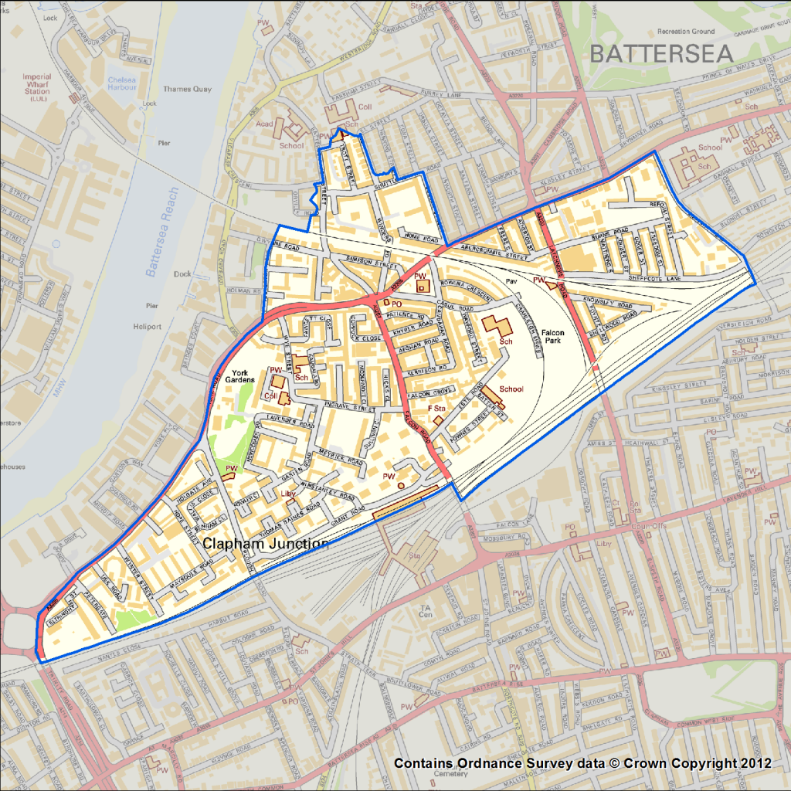

Principle data sources: Big Local SW11, 2014-2018; Census, 2011; Citizens Advice Wandsworth, 2015/16; DCLG’s IMD, 2015; London Poverty Profile, 2017; Public Health England, 2017; Wandsworth JSNA, 2018
Social Capital: the ‘bonds’ that tie people, the ‘bridges’ that connect people, the places and spaces where people meet.
10% of Battersea’s population

