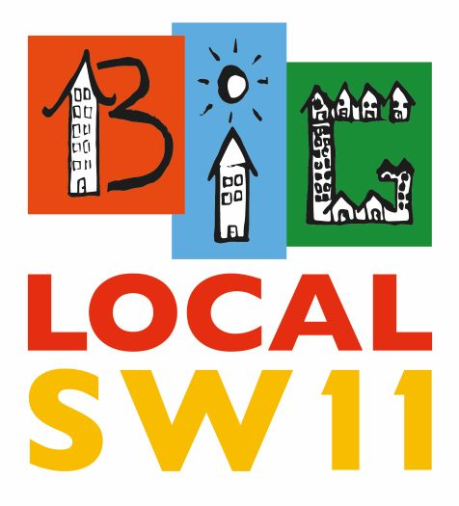
BLSW11 Grants Programme 2020

Summary of Our Journey

2013-15
During our early stages of consultation and engagement, the grants programme developed a ‘quick wins’ approach to show support for local groups. The application process broadly followed Local Trust Guide Lines.
A number of ‘ad hoc’ projects were funded but we did not follow up or evaluate them.
2016-17
A review of the Grants Programme concluded that it was too bureaucratic (top down) and did not reflect our aims and objectives; and that a revised programme should:
- Be easier to access
- Have a simpler application process
- Engage with applicants to discuss ideas and provide support
- Link our support to our aims and objectives
- Try and identify projects that might have the potential to become permanent and self-funded
2018-19
The re-launched programme had a much simpler application form accessible on-line or in hardcopy. Our focus was on SEED funding and new ideas. We aimed not to duplicate existing funding or take on projects that had lost their funding.
We introduced a ‘pre-application’ process that enabled the Grants panel to meet with people after they had made an initial enquiry, so that we could discuss how the project idea might be developed.
We developed monitoring and evaluation to both assess the ‘value’ and/or impact of our support, and to judge whether the project should be offered further support.
Reporting on the management and delivery of our Grants Programme has been a standing item at PC meetings. A report on applications, grant awards and outcomes for 2018-19 can be accessed here: https://drive.google.com/file/d/1iOWpef-zkMcJr6bqS0C_gwbLf2N5ObOq/view?usp=sharing
An account of successful BLSW11 grant aided projects is given on our web page here: https://www.biglocalsw11.co.uk/grant-programme-closed/

2020 – A New Direction
A second review of our grants programme in 2019 concluded that it should be continued but that further improvements could be made that linked awards to tackling isolation, loneliness, mental health (anxiety and depression) as well as favouring community based initiatives. In particular the new programme should:
- Should be for helping new projects to get started and to expand the reach – not repeat funding and not for the same closed group of people
- Ensure that when a project has been funded or a year or two advice would be given on getting funding from outside charitable trusts
- Ensure that established groups asking for funding for new projects should argue why they could not try established charitable trusts
- That any project which was funded would be expected to give a report back – looking at what could have been done better, how it had reached new people, etc.
- Provide that one off grants would be granted if it was felt there would be a longer term benefit, e.g., getting people involved who weren’t otherwise.

Sharon Grant Fund
Sharon Grant was a founder member of BLSW11 and a powerful advocate for the most disadvantaged in our community. Sharon had a particular interest in mental health and well being and it would be fitting if we could commemorate her involvement with us by setting up a grant fund in her name.
We therefore propose to use our grant fund (currently £20k a year with the prospect of match funding being secured soon) to launch a fund raising campaign to see if we can attract significant new funding into the BLSW11 area in order to provide a ‘safe place’ for local people, who may be in need of support, advice and/or guidance.
If this proposal is agreed by the BLSW11 Partnership Committee (PC) our grants Sub-committee will, after consultation with and the endorsement of Sharon’s family, lead in seeking to work with other local organisations and community members to develop a campaign over a six to nine month period.
The outcome of the campaign will be reported back to the PC ahead of any financial commitments being made.

Next Steps
We propose to re-launch the Grants programme in March 2020 with a renewed emphasis on making the process as accessible as possible for local residents and community members, with a stronger focus on using our limited resources to support project ideas that address Loneliness, Isolation, Mental Health (Anxiety and Depression).
We intent to create opportunities for local people to meet with members of the Grants Panel to discuss their ideas before the application process in a variety of local settings (Kambala, KLS, Providence, Caius, St Peter’s and Carney’s Community, are options).
Our community members will be able to contact us via letter, email, online, social media and word of mouth. We will particularly keen to support pilot projects that have the potential to become sustainable and will work with local people to guide them through the process of accessing BLSW11 support.

Donna Barham
Chair

