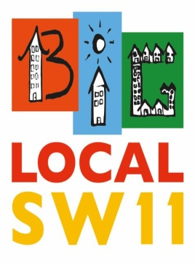

Platform One - BLSW11 Discussion Document for a Community Hub

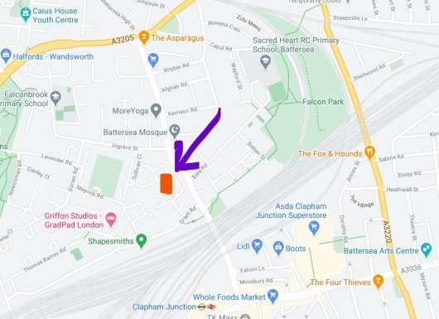
- The Concept
  - The Platform One building is ideally located for a community hub to be established in the heart of the BLSW11 area and as a gateway feature of the regeneration programme for Winstanley and York Road.

  - A BLSW11 Alliance Hub (say Battersea Alliance Community Hub – BACH) should not be ‘owned’ or used as the main venue for any single organisation, but rather provide a focus for multiple community uses, managed by the Alliance in furtherance of its strategic aims - building social capital in Battersea with a particular focus on tackling loneliness and mental health (Anxiety and Depression).

  - The idea is that premises become known as community resource rather than a service; with local groups and individual having an opportunity to trial new projects or develop existing ones.

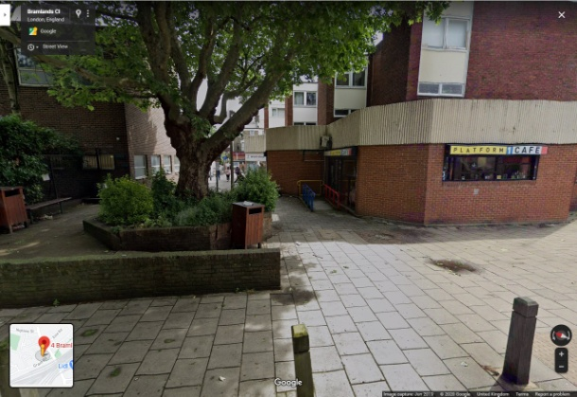
  - A three year community development and engagement programme is proposed with options to extend this indefinitely should the uses prove to be viable.

  - Working on the principle of ‘can pay, will pay’, statutory and well established charities will be expected to pay the market rate for hiring the premises; community groups and pilot projects would be free of charge.

  - The facilities will be available from 8:00am to 10:00pm 7 days a week (98 hours) and will require professional management and caretaking (a revenue cost that will be met by BLSW11 and the Alliance and subject to further fund raising after one year).

Uses
  - The potential uses far exceed the capacity of a single, relatively small premise but consideration will be given to:

- A focal point for BLSW11 Alliance to promote its activities and engage with local people
- An information and referral hub for Alliance member organisations (Carney’s Community, Caius House, Providence House, St Peter’s Battersea, Katherine Low Settlement and BLSW11)
- Information, advice and guidance (based on the successful BLSW11 pilot ‘Building Futures’ project)
- Satellite provision for Citizen’s Advice Bureau, Age UK, Share, Mind, etc.
- ‘Recovery Cafe’ – for people with mental health challenges
- ‘Hot desking’ for local people/groups
- Meeting rooms for events, workshops, training
- Access to IT equipment and IT support
- Mentoring (linked to Carney’s Community and JCT)
- Transitional Work (in the first instance Young people in Care or Fostered)
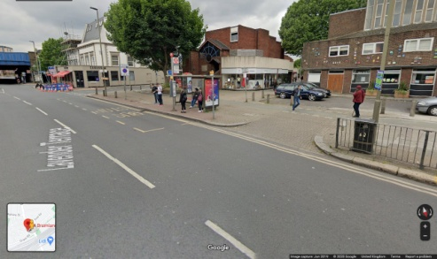
- Mental Health Support (Drop in, safe space, guidance)
- Healthy Cooking/Eating Sessions
- Training facilities
- Craft workshops
- Arts and Cultural projects (linked to Providence House)

  - In addition the external space could be used for Summer events, exhibitions, music and other activities, to create a dynamic ‘street scene’.

- Considerations
  - Platform One is currently being used by Waste Not Want Not (WNWN) for approximately 20 hours a week, with associated use of the kitchen, and a need for storage space.

  - It is proposed that WNWN is incorporated into the BACH scheme based on actual hours used.

  - The premises are located adjacent to Providence House and ways of integrating or combining uses should be considered.

  - The site lies along the desire line from Falcon Road to Clapham Junction station and could form part of an upgraded thoroughfare.

  - We anticipate the scheme being agreed on terms of a peppercorn rent and 100% Business Rate relief.

- Design (Refurbishments)
  - The current layout of the premises allows for multiple uses but with modest adaptations and some refurbishment the range of operational uses could be increased.

  - In response to Covid-19, special consideration should be given to air quality, ventilation and high specification air conditioning.

  - The current fixed partition could be removed and replaced with a flexible partitioning scheme to allow for more configurations of the space.

  - There is inadequate storage which could be addressed by internal and external adaptations.

  - Furniture and equipment should be easily adapted for multiple uses and easily stored when not needed.

  - IT equipment could be upgraded to allow for more flexible use of technology, including a White Board, Video Conferencing, Multi-media presentations, etc.

  - The toilets need a significant improvement.

  - The current office space is inadequate and needs upgrading.

  - An Awning could be built into the side to enable all weather use of the forecourt area, which along with the existing raised beds and planters could be further developed as part of the scheme.

  - The costs for refurbishment could be met from the Wandsworth Local Fund element of Community Investment Levy associated with the redevelopment of the Winstanley and York Road Estates.

- Management
  - The BACH will require a full time centre and facilities manager and caretaker services. Additional capacity may be secured through volunteers.

  - The manager would be responsible for marketing, promotion, bookings and on site supervision.

  - The manager will be employed by BLSW11 Alliance and accountable to a member organisation.

  - The revenue costs for the scheme will be met by BLSW11 Alliance and BLSW11 Community and Belonging budgets with further match funding to be secured before the full scheme is developed.

  - Final approval will be required by the BLSW11 Partnership Committee and the Executive of the Alliance.

- Cost Estimates
  - Based on crude comparisons with buildings that are currently managed by Alliance members we estimate the centre and facilities management costs at £80k a year; including:

- Salaries £60000
- Utilities £3000
- Materials £2000
- Volunteers £5000
- Fees £10000

  - We propose that 50% of the costs are met from a combined Alliance/BLSW Budget @ £20k each =£40k with the outstanding £40k to be secured through match funding.

  - We anticipate capital costs of approximately £200k to be met from Wandsworth Local Fund.

- Next Steps
A leasehold agreement is needed between the current owner (LBW) and the BLSW11 Alliance. We suggest a three year lease at a peppercorn rent, subject to renewal; with a one year break clause.

  - A refurbishment scheme should be designed and a Wandsworth Local Fund application submitted.

  - A job description and person specification for a BACH manager should be prepared.

  - BACH could be operational while refurbishment is planned and implemented.

January 2021

