Community & Belonging Forum (CBF)

Community ‘Champions’ (For discussion)
Identifying and working with ‘Community Champions’ was an aim of the first BLSW11 Plan that was never developed!
Now the CBF wants to look again at establishing a network of community champions who can ensure that every part of the BLSW11 ‘patch’ is covered in terms of some form of representation.
This is particularly of concern for parts of the patch that have not benefitted from BLSW11 spending or projects.
Now, with the development of the Alliance and CBF’s ambitions to work in Partnership with others, it is timely that the idea of community champions is revisited.
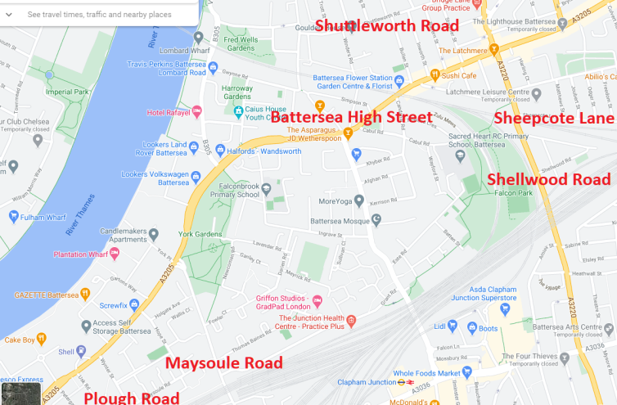
The BLSW11 area includes Maysoule Road (W), Plough Road (W), Winstanley Road (C), York Road (C), Ingrave Street (C), Este Road (C), Khyber Road (C), Coppock Close (C), Shellwood Road (E), Sheepcote Lane (E), Battersea High Street (N), and Shuttleworth Road (N)
And we judge that Maysoule Road, Plough Road, Shellwood Road, Battersea High Street, Shuttleworth Road and Sheepcote Lane, are areas that have benefitted the least from BLSW11 support and it is in these areas that the CBF would like to consider how local people can influence how our resources can best be used to strengthen the communities.
Imagined Case Study
An active member of the community and resident of Plough Road, ‘Jane’ is aware that her neighbourhood does not have a residents association or other community organisation. She is invited to join the CBF and become a ‘community champion’.
In this role she is made aware of all the CBF and BLSW11 Alliance initiatives that are underway or planned; and the resources (financial, human, volunteers, partnerships, publicity, influence) that could be mobilised to encourage local community involvement in her area.
She is able to act as a go between, informing her residents and inviting suggestions; perhaps she sets up a neighbourhood WhatsApp group and proposes to run a street party (post Covid) to bring the residents together. She is aware that many people in her area have no broadband or WiFi and struggle to access online support or information and, through the CBF joins the ‘digital inclusion’ project managed by KLS and through this gains access to IT equipment and technological support for local people.

Jane is aware of a number of people that are chronically lonely and through the CBF she connects with Battersea Befrienders and kick- starts the process of linking volunteers to vulnerable individuals.
In a similar way she is able to communicate with local residents about:
- The BLSW11 Alliance Covid-19 Community Support Fund and its probable successor fund
- The CBF plans to address depression and anxiety
- The Guy’s Room project
- The Living Rooms initiative
- Falcon Road Festival
- The Alliances initiatives for young people
- Other funding opportunities
- The discussions about use of Platform One
Then suppose that this experience is repeated across the four or five most neglected parts of the BLSW11 patch!
Each ‘champion’ could focus on the area that they know best but through sharing knowledge and information, provide a rationale for a more strategic approach to community engagement and resident involvement.
This proposal would not necessarily require a dedicated budget, but the ‘champions’ would need to have the confidence that their involvement with CBF will have an influence over future resource allocations.

March 2021

