Summary of Delivery (500 words)
What did you do? Where? How did you promote? Who attended?
The Zumba classes have been a great success. With Big Local funding, the Penethorne Residents Association and Katherine Low Settlement started up a women’s fitness group in Pennethorne House on Wenesday mornings from 10am – 11am, specifically aimed at mums from ethnic minorities who didn’t do much exercise previously. Flyers were distributed and members of local mothers groups were encouraged to come. Turnout from the start was excellent, and they were so keen that the class also runs on Tuesday mornings, for no extra cost, with an equally high and consistent attendance rate. The women will now be paying for the course themselves and so the project will be sustained in the long-term and provide the on-going health benefits. All attendees are from the Big Local Area.

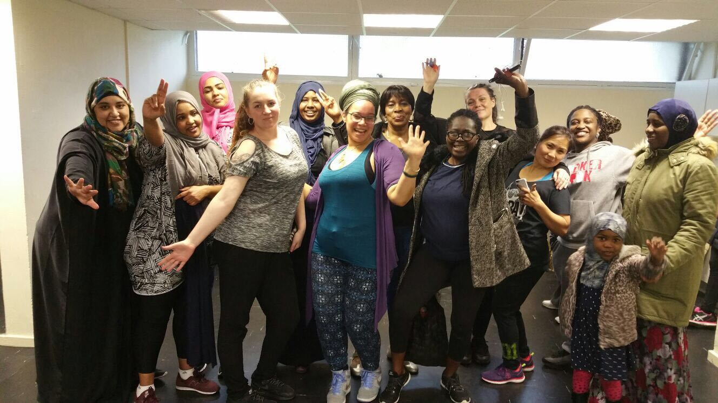

Demographic Data
 | Unique Participants |  | Total Attendances
 | BLSW11 Residents | Non-Residents | BLSW11 Residents | Non-Residents
Male
Female | 60 |  | 213
Unknown
18-29 | 5%
30-39 | 50%
40-49 | 20%
50-59 | 20%
60-69 | 5%
70-79 | 0
80-89 | 0
90+ | 0
Unknown
White | 5%
Black/Black British | 50%
Asian/Asian British | 40%
Mixed | 5%
Chinese
Other
Unknown
Visual disability
Learning disability | 5%
Hearing disability
Physical disability | 5%
No disability

Progress Towards Key Performance Indicators
Key Performance Indicator (KPI) | Project Target | Actual Output | Explanation of progress towards KPIs  (250 words per KPI maximum)
- Number of individuals attending a session | 15 | 60 | - We exceeded the target number of 15 people attending sessions, with 60 people in total attending at least one of the Tuesday or Wednesday sessions during the 10 weeks. Every week there was a full (and sweaty) room of women who didn't previously do exercise.
- Total number of attendances at a session |  | 213 | - A total number of 213 sessions were attended by 60 participants.  - 14 came to 1 session  - 10 to 2 sessions  - 6 to 3 sessions  - 6 to 4 sessions  - 4 to 5 sessions  - 5 to 6 sessions  - 3 to 7sessions  - 7 to 8 or more sessions
- Number of individuals attending 8 sessions or more  (6 or more if you delivered 8 sessions) |  |  | - 7 people went to 8 or more sessions
- Number of inactive people joining a session  (0 days of activity in past 7 days) |  |  | 3 from the sample group of 20 were inactive and 4 recorded one activity session in the last week.
- Number of people increasing activity levels  (reporting more days active in past 7 days than at the start) |  |  | - Out of the 60 people, everyone who attended only 1 or 2 sessions can be discounted, resulting in 46 people increasing their activity levels by attending 3 or more sessions.
Key successes and achievements (300 words)
What went well? Was there a significant impact? What did participants tell you?
The promotion was successful, with lots of women hearing about it as a result of promotion and support of the Pennethorne Residents Association. They all live in or near Pennethorne House and word about the group spread quickly.

The venue was key to the success of the group – being in Pennethorne House made it easy for residents of the block and the surrounding homes to come along. This brought in people for whom travelling somewhere to exercise would have put them off, and also made it more acheivable between school and nursery drop offs for mums.

Having a Zumba class appealed to women and the music and type of exercise is fun and able to be done from a low level of fitness to higher levels.

The trainer was very motivating and made the sessions enjoyable, Marine also offered diet and nutrition advice and gave motivational pep talks to everyone to encourage them to set goals and encourage fitness.

There was a high attendance level from the start so the room always seemed full which made it attractive to people to want to come along and see what was happening.

The main indicator of success was that women wanted an extra session each week so it quickly expanded from just Wednesdays to Tuesdays and that more the ne necessary 15 women have signed up to pay themselves to carry on doing the classes.

One attendee said 'I had no interest in exercise before and took advantage of the free lessons but I cannot image a life without my Zumba classes and Marine! I feel so much fitter, advice and encouragment with diet has helped me so much with my health. I have made friends – everyone is friendly and we support each other. I LOVE ZUMBA!'

Key issues and learning (300 words)
What didn’t go well? What barriers did you face? What have you learnt for the future?
24 people didn't attend for more than 2 sessions, and most people didn't attend all the sessions. Religious and school holidays were given as the main reason for non-attendance on a couple of the weeks – for example in half-term. They did then come back after half-term which showed a willingness to keep up exercise.

The main barrier to some women is just being busy mums. Some women tried the classes and didn't carry on as it wasn't for them and they main reported just being too busy for the classes.

We have learnt that the venue is key – having exercise nearby removes a big barrier, that Zumba is a good form of exercise for this target group as it is fun and dance based, and that nutrional advice alongside exercise really helps motivate women to change their whole lifestyle to be more healthy.

Sustaining for the future and recommendations (500 words)
How will you sustain the activity of the people you have engaged? What advice would you give others in the future?
Attendees were asked if they wanted to continue with the group and

Advice would be to hold classes in the area you want to encourage women to attend from, to have women-only classes to appeal to BAME women and older women, and to advertise the on-going costs (£25 for 10 weeks in this case) from the start so that women expected it rather than putting them off at the end – this was good advice from Enable that we took and which worked.

Budget Reconciliation
Please detail below how much you have spent for each budget line. We may request to see invoices and receipts detailing these costs.

Expenditure | Original Budget | Actual Spend | In kind – Yes / No
Coaching/ Instructor costs | £200 | £200
Equipment | £399 | £219.99 for PA system  £161.73 for yoga mats and dumbells
Venue hire | £150 | £150
Marketing e.g. printing | £140 | £140
Advertising | £ | £
Public Liability Insurance | £ | £
Administration e.g. postage | £ | £
Catering | £ | £
Transport | £ | £
Other (please explain) | £ | £
Total Expenditure | £889.00 | £871.72
Income (please give further details including organisation names etc.)
In kind support | £ | £ | Staff support for employing the instructor, arranging the venue, promotion, recruitment, evaluation and on-going support
Other (please explain) | £ | £
BLSW11 Fitness Movement Grant | £889.00 | £889.99
Total Income | £889.00 | £889.00

