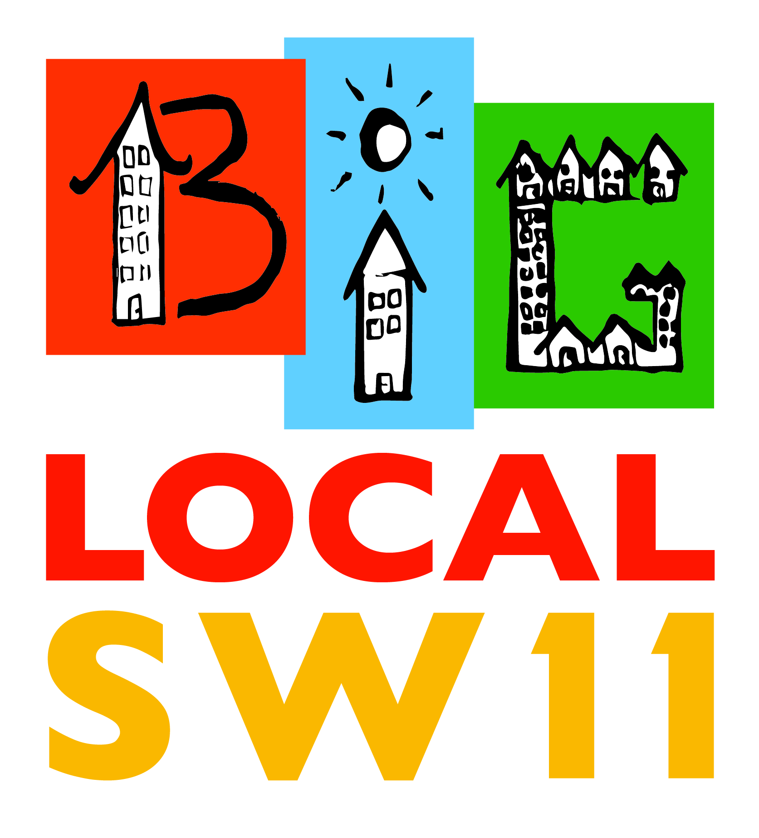

Big Local SW11
State of the Sector Report

August 2018

Contents
Executive Summary 1
Purpose 1
Methodology 1
Key Findings 1
1. Introduction 2
2. Methodology 3
3. Findings 4
4. Implications and Follow-up 5
Funding 5
Information and Advice 5
Research and Evidence 5
Networks 5
Evaluation 5
Appendix 1: Organisations 6
Appendix 2: Survey 8
Appendix 3: Comparisons 9

Executive Summary

Purpose
During

Methodology
Our first Battersea

Key Findings
From the outset it was decided that our approach to partnerships would be based on

Introduction
  - The
  - The
  - The

Methodology
  - The
  - The
  - The

Findings
  - The
  - The
  - The

Implications and Follow-up
  - The

Funding
The

Information and Advice
The

Research and Evidence
The

Networks
The

Evaluation
The

  - The

For 2017-18 we are developing a completely new approach based on the BLSW Strategic Partnership.

Appendix 1: Organisations

Organisation
Battersea Chapel
Battersea Methodist Mission
Battersea Power Station Development Company
Black Heros Foundation
Carrot Cake Nursery
Cheer Trust
Christchurch CE Primary
Christians Against Poverty (CAP)
Church of the Nazarene
Clapham Junction Medical Practice
Croatian Church Trust
Faithful Living
George Potter House Nursing Home
George Shearing Centre
Haven Lodge
Holmleigh Court
Home-Start Wandsworth
Kambala Estate Residents Association
Latchmere Leisure Centre
Link-Up Battersea (referrals from Wandsworth Mediation Service
Mercy Foundation Centre
Mimosa Women's Support Group
Battersea Fitness & Wellbeing Centre (Nuffield Health
Sacred Heart Primary School
Safe Ground
Share Community
Sir Walter St John's Educational Charity
Junction Community Trust - Spear (Clapham Junction)
S.T.O.R.M Family Centre
Thrive (formerly Society for Horticultural Therapy)
Victim Support
Referral from Life Long Learning
Wandsworth Foodbank
Wandsworth Heritage Service
Wandsworth Law Centre
Wandsworth Community Empowerment Network
York Gardens Library
Katherine Low Settlement (KLS)
Birhan Dagne
Falcon Estate Residents Association
Pennethorne House Residents Association
Waste Not, Want Not Project
Wilditch Community Centre
Wow Mums
Sentalk
Platform One Cafe
Scholey House Residents Association
Providence House
St Peter's Church
Carney's Community
Caius House

Appendix 2: Survey
Community Organisations in BLSW11
Organisation
Name
Contact details (Update)
Name
Address
Email
Telephone
Social Media (Web, Face Book, etc)

Constitution (Charity, Community Interest Company, etc)
Theme (Education, Health, Young People, Disability, Housing, Advice, etc)

Activities

Target Group(s)

Number of Staff (Full Time Equivalent)

Number of Volunteers

Volunteer Hours (per week)

Turnover

% of Turnover from Grants

Are you aware of BLSW11?

Did you attend the Falcon Road Festival?

Do you want to be kept informed of BLSW11 activities?

Would you consider becoming involved with BLSW11?

We would like to promote you on our Web site, is this OK?

Appendix 3: Comparisons

