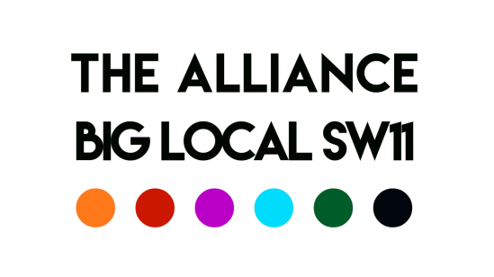

Meeting of the 21st May 2020

Chair: Robert Note taker: Charlie
Present: Aaron, George, Del, Charlie, Esther, Robert, David, Syeda
Item | Action/Updates | Lead
Catch-up | Del: Everything churning along nicely  Charlie: Cooking weekly meals for Holmleigh Court but have more capacity (offered help to Syeda if she needs any relief). Beginning to mail out to local area to see if anyone wants weekly meals. Posting masks (from a local sewing group) to elderly and vulnerable in community.  Syeda: Really tired from making 200 meals this week. The Coivid19 fund is taking a breather to do a refresh - they literally started in 2 days of the mandate and gave out monies to worthwhile causes. Stephen feels we need to step back to make sure we have our ducks in a row. Will let you know once we’ve got finalisation of things. There will be no meeting this week or next.  George: Started doing one-to-one boxing fitness sessions in the park, there have been 3 stabbings in Wandsworth since the lifting but not gang connected so unsure what’s going on with that. ‘Carney’s Conversations’ kick off today with interview with Stormzy- interviewing ex participants and people wo can provide inspiration for young people. If anyone is aware of anyone to have on let us know  Esther: Radio shows still going, this week a tribute to sport, featuring providence and carney’s young people. Next week around Providence house and lockdown, Caius house girls writing poems and recording them integration from groups.  - Set up lockdown Youth awards - 5 Lockdown awards nominations different categories, parent can nominate them anyone up to the age of 25 looking to celebrate as many young people as we can. Closing date tbc. Planning an awards radio show.  - For the track for the We’ll Meet Again – making a video submitted to online national arts fringe who want to use as a closing feature.  Aaron: life getting more routine for us, planning for some return in the future thinking through complex ways on how we might do that. It’s tricky as the groups are vulnerable, possibly opening September  - Has 4000 cloth masks with antibacterial film over them, washable available to anyone who wants them  - Have been working around Surrey Lane Estates trying to get a community centre around there. Back on the planning application rota process for the council, putting together a business plan at the moment. 98% of residents from a door knocking survey by St Mary’s said they wanted a community centre. Will keep the Alliance up to date on progress.  Robert: considering re-opening in a small way in July or summer holidays. | Del  Charlie  Syeda  George  Esther  Aaron
Recruitment | Battersea Youth Voice – agreed to start recruitment  The Advert doesn’t need to say interview date. If closing date is June then we have time to think about how to conduct interviews. Youth voice is ready bar compiling an advert and deciding where it’s going to go  Volunteer Coordinator – agreed to start recruitment; Aaron and Robert to review and report back to next meeting. David to send details of Volunteer Coordinator to Charlie. | Del/George/Esther  Aaron
AOB | Aaron - Battersea Charities week (communities month) was happening in June but is postponed  Robert – reminded the group that there is funded collaboration that we do for which we need BL Partnership approval (as with Battersea Youth Voice), Alliance initiative work for which we are expected to report (as with Battersea Charities Month) and good collaborations that we do anyway and which we record in these notes (Youth-Battersea website and its linked activities are an example of these)  Esther – communities week and festival we can’t do things as we normally would, do we need to think about something that shows we are present in doing something. Eg. virtual festivals, communities month or week under the banner of the Big Local and the Alliance we don’t want to lose  David – we could use our networks for a kind of celebration at the end of August that showcases positive stories  Charlie – thinking about an idea based on local physical installations. (To look at Rev Betsy minister for the Arts in Nine Elms ideas)  Esther – Maybe Riverside radio could do a longer festival show, like they did for VE day - have something sent round that people could do in their own home, stuff to listen to and stuff to see, end of August would give us time to bring other organisation ins  David – Some Good News going across USA where someone orchestrates personal accounts or groups/families about what people are doing it is heart warming. Quasi celebration and recognition of what’s going on  Robert – Could have a road show at 8pm and perform in the street sing tell a story, socially distanced  Esther – the Yes perfomrers  David – David to put out an email invitation to a Zoom meeting (first week of June) specifically about this idea. To write a paragraph about what the content might be, something that uplifts and has a community focus. | All
Date of Next Meeting: ^{4th} June 2020; 10:00

