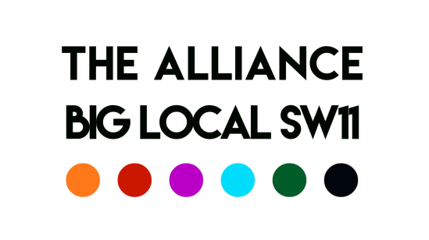
Meeting of the 9th April 2020

Chair: Robert Note taker: David
Present: Aaron, Charlie, Del, Esther, Robert, George, Syeda, David
Actions
Subject | Action | Lead
Minutes | Minutes of previous meeting to be circulated to BLSW11 | SI
Covid-19 | Syeda gave a progress report on the BLSW11 Alliance Covid-19 Fund launch on the 2nd April  It was agreed that everyone would promote this on web sites and through networks  Robert reported that Big Local £50k should be paid soon.  JV £50k confirmed, AB to arrange payment  It was agreed that alongside the Covid-19 Fund for the most vulnerable in Battersea, the Alliance should consider the impact on the Sector – this will require some research. David agreed to lead | SI  All  RM  AB  DS
Battersea Youth Voice | Agreed to delay recruitment  Esther, George and Del to meet next week to consider developing a ‘pilot’ scheme about Covid-19 and young people | GT/E/DT
Battersea Volunteer Coordinator | It was agreed to postpone recruitment | All
Funding for the Sector | London Funders  Charities Aid Foundation  NCVO  LB Wandsworth Covid-19 Community Fund | All
YES | Great success, but needs to be built on! Esther and Del to look at other ways to communicate YES event(s)  Battersea Youth web site up! https://www.youth-battersea.co.uk/ Managed by Del | E/DT  DT

Date of Next Meeting: 16th April, 10:00 Zoom

