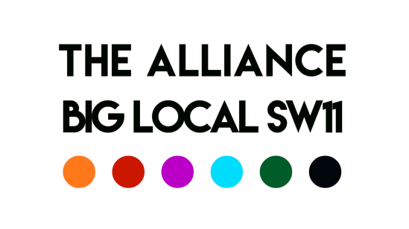
Meeting of the 16th April 2020
Chair: Robert Note taker: David
Present: Aaron, Del, Robert, George, Syeda, David
Apologies: Charlie, Esther
Actions
Subject | Action | Lead
Updates | Del: LBW have assigned Youth Workers to Caius  Eversley (Plantation Wharf) to assist with Battersea Youth web site.  George: Online Boxing lessons being delivered; food deliveries underway  Aaron: Befriending Scheme to be launched with 350 volunteers and 145 families, designed to provide support addressing isolation, depression/anxiety  KLS developing Corona Club to deliver homework online  Power to Connect – Battersea Power Station wants to explore linking its power to connect initiative (addressing digital exclusion) with the Alliance  AFC Wimbledon – ‘Dons Local Action Group’ initiative to mobilise up to a 1000 volunteers  Syeda: Covid-19 Fund operational; one application to FERA approved and payment of £5000 made; others under consideration  Application process: Weekly assessment deadline each Thursday; decisions on the following Friday  YES (Part 2) – following up meeting being arranged  Robert: Providence developing Online children’s meetings | Del  Del  George  Aaron  Aaron  Aaron  Aaron  Syeda  Syeda  Del/George  Robert
Covid-19 | Coordination issues: Aaron is part of a regular updating arrangement with LBW, Charities and other organisations  Research: David in discussion with JV about sharing resources to undertake research into the impact of Covid-19 on community groups and organisations in Battersea | Aaron  David
Battersea Youth Voice | Esther, George and Del to meet next to consider developing a ‘pilot’ scheme about Covid-19 and young people | GT/E/DT

Date of Next Meeting: 23rd April, 10:00 Zoom

