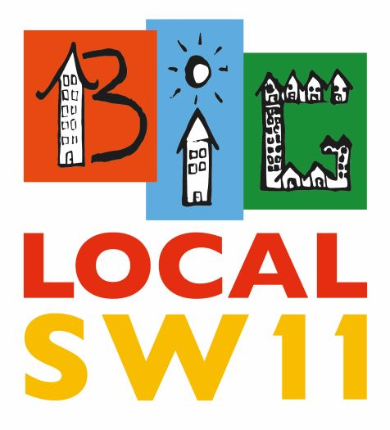
Minutes of BigLocalSW11 PC Meeting 6.2.20
1. Attendance:
Stephen Holgrove, Robert Musgrave, Wendy Speck, Donna Barham, Syeda Islam, Senia Dedic, Tessa Strickland, Jennie Fortune, Marlene Price, Amardeep Kainth, Felli Ubralti, Lisa Idrisa, Helen Taylor, Mario Desouza
Also present: David Stone
Apologies: Kate Stock
2.Minutes of the meeting of 14.11.19
These were accepted with minor amendment from Stephen, submitted to the meeting- ie. Change international to intergenerational subcommittee which Wendy Speck chairs.
3. Matters Arising
Stephen explained how the Executive Committee has been formed to implement the actions agreed upon by the Partnership Committee (PC), and referred the meeting to the Terms of Reference, which were agreed
The PC is concerned with the Strategic overview, the Big Picture etc
The Executive Committee sorts out the details and makes sure that things get done.
Stephen explained that it was the difference between Material and Non Material changes, which would be added to the terms of reference
Therefore
Material changes affect outcomes, significant changes to delivery and budget – and these come back to the PC
Non Material changes include small decisions but do not affect the outcomes, budget or significantly change the delivery of our Strategic Plan and these can be made by the EC
4. Communications
a) Helen presented slides about understanding the way we as a BigLocalSW11 had evolved and communications within the Committee.
A paper had been circulated prior to the meeting about how communications worked and were being improved, which included minutes being sent out quickly after the meetings, work on the website and communicating together eg Alliance, ourselves and Battersea Together
b) the meeting then looked at the development of the local network of individuals and organisations and how working with others enable us to mobilise resources, expertise etc to make the community stronger. Tracking the journey of this to show how the work of ourselves and the Alliance and our 3 year plan all came together. Developing our Community Network was key and now money was going to be coming from the local developers, to match fund projects from our three year plan, which amounted to over £120,000 per year for three years. This would go through the Alliance for work such as Youth Voice, Volunteers etc, and it was only through bidding via the Alliance that we were able to get the money
Robert explained how this will work and will include discussions with our the EC. It is funding in order to fulfil our programme
Where the filling posts are concerned, it was agreed that residency in the local community should be considered as desirable and taken into account when appointing.
Nevertheless priority would be to get the best practitioner for the job

5. Budget
Robert presented the budget and the Local Trust has now been asked to forward money so we will be able to fulfil our programme in the coming year.

6. Current Projects
a) Alliance and Battersea Youth Voice
The report had already been circulated. This would be a Youth led network, not currently covered in present groups and aiming at young people not already involved. There will be a full time worker, based at Caius, but covering the whole area. The Alliance fine tuned this and we have now got match funding.
This was ratified by the PC
b) Intergenerational Report
This was circulated prior to the meeting. Wendy explained next steps, including setting up a Battersea together type networking meeting to get all those with experience in the area together. This will be organised by the intergenerational committee. Extra people on this from the PC also include Senia, Felli and Donna. And it is hoped that others from the local community can be involved, even if not voting members
This will hopefully be pulling together a fragmented area of work.
It was agreed that this networking continue with its findings being presented at the next meeting.
c) Small grants
See report circulated by Donna. This charted our progress so far, but going forward will be linking towards loneliness etc – i.e. the main aims in our strategy. We want to make it as accessible as possible and people can be helped to fill in a grant form
It was also proposed that a Sharon Grant Fund was set up, following the death of the previous chair of the small grants committee. This would be a subsection of grants
Donna explained how we will seek support from the Alliance to match fund our Grants budget, and from this combined fund we (BLSW11 and the Alliance) seek to secure additional support from a variety of potential funders.
It was agreed that this approach should be explored further and presented at the next meeting.
d) Falcon Road Festival
The original date was 27th June, but now changed to 4th July, because of clashes with various other events. Current Members of the Planning Team include: Marlene (Chair), Jason Rosam (Riverside Radio), Ian Taitte (Think Events), Senia Dedic, Micky Gwilliam (Falcon Estate), Nick Atkins (Enable), Tessa Strickland, Catherine Keevil, Donna Barham, David Stone.
The Committee asked for the release of £15000 towards the cost in the Plan and this was agreed
7. Support Worker/consultant
David’s contract had been renewed with an increase in fees
8. Outreach worker post
A job description has been done previously. It was agreed to go ahead with this
9. New members on the PEC
New members were given the opportunity to speak, say which committees they wanted to be on etc
AOB
- Code of conduct was raised – Governance to consider and report back

- Amardeep raised the fact that we were missing out on opportunities on local offers and support. She agreed to send us particularly useful e-mails on relevant events etc

Date of Next Meeting: 4th May 2020, 10:00am, Providence House

