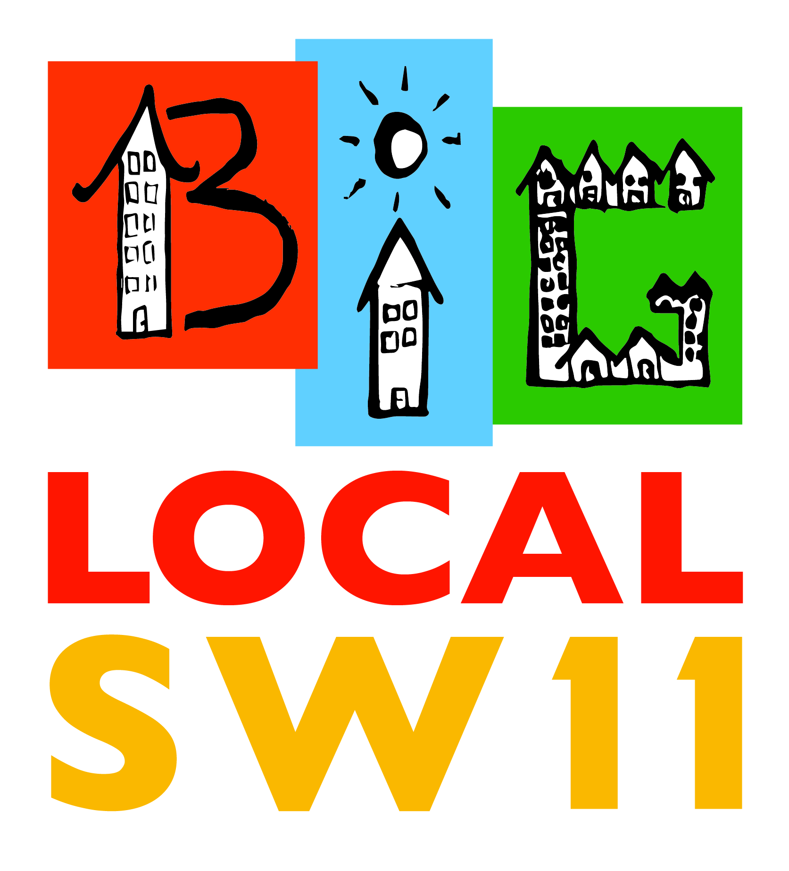
BIG LOCAL SW11 GRANTS APPLICATION FORM

Information needed about your project proposal
Name of applicant or organisation
Contact name
Postal address
Contact telephone number
Email address
Describe your Project in no more than 300 words.
How many people would benefit from your Project?
Of these, how many live or work in the BLSW11 area?
How do you know that there is an interest in your Project?
How will your Project be promoted?
How or why would this project make a difference?
Is your Project targeted at a specific group? If so, say who.
Overall cost of the Project
Grant Applied for
Provide a breakdown of how the money would be spent.
Will you be seeking to match the BLSW11 Grant from other sources? If so, who?
How would you describe and measure the success of your Project?
Number of staff/volunteers involved in the Project.
Please give a proposed start and end date of the Project.

Signed ……………………………………………… (Insert name if sent by email)

Terms and Conditions:

- Applications will only be considered for individuals, community organisations or businesses that are in or serve the BLSW11 geographical area (see map on website: http://www.biglocalsw11.co.uk)

- Priority will be given to projects that most match the BLSW11 vision and values (see advertising poster or go to our web site).

- Individuals/organisations that have previously applied for BLSW11 grants are welcome to apply again, but projects previously awarded but not completed will not be considered.

- Each successful project will be required to sign a grant acceptance form, and submit a monitoring and evaluation report (template provided by BLSW11). The information from these may be used on our website and in other media.

- If required each project will be responsible for insurance cover and compliance with statutory provisions (Safeguarding, Child Protection, DBS, etc)

- BLSW11 will accept no liability for any damages or costs incurred by or for your project.

- Funding may include volunteer and staff costs, but should not be used for:

- Activities volunteers or staff undertake as part of their normal employment
- political or religious activities
- projects or activities that there is a mandatory obligation to provide; and
- VAT that can be recovered for general running costs not associated with the delivery of the project.

The BLSW11 Grants programme is being managed by Community Voice which is a subcommittee of the BLSW11 Partnership Committee led by Sharon Grant.

If you want to discuss your project idea before submitting an application, contact David Stone on 07950013153 or email: david@biglocalsw11.co.uk
Applications can be submitted online at: http://www.biglocalsw11.co.uk/big-local-sw11-grant-2017-2018-online-application/
Or by email to: david@biglocalsw11.co.uk
Or by hand/post to: Sharon Grant c/o Big Local SW11, Providence House, 138 Falcon Road, London, SW11 2LW

