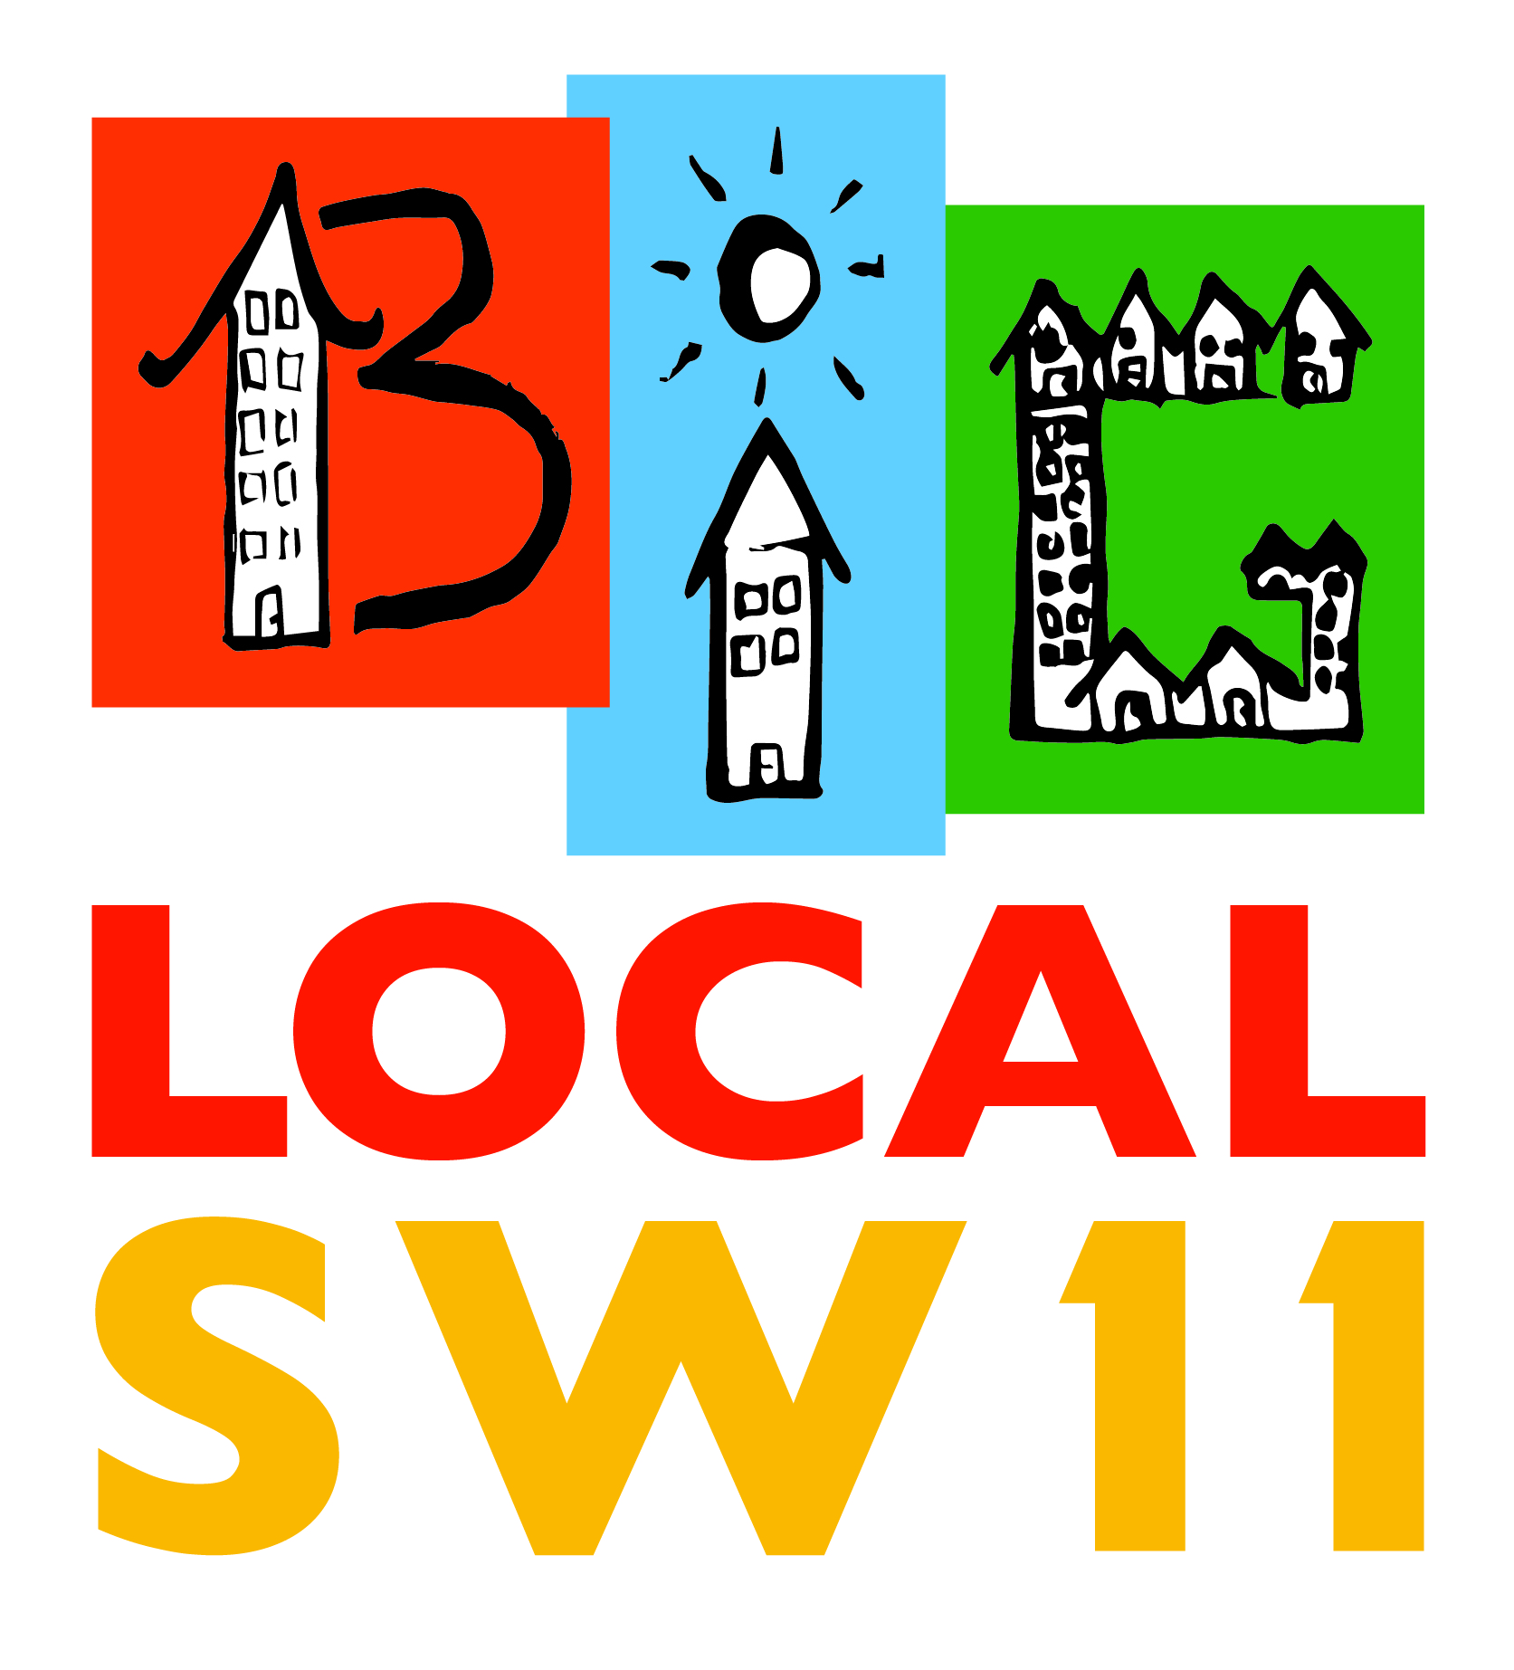

Big Local SW11
Plan and Budget 2017-18

Contents
Summary 2016-17 1
Developing Partnerships 3
BLSW11 Strategic Partnership 3
Why these organisations? 5
Benefits 5
Management 6
Our Plan for 2017-18 7
The BLSW11 Strategic Partnership 7
Intergenerational Programme 7
Falcon Road Festival 7
BLSW11 Grants Programme 8
Outreach 9
Budget 10
Proposed budget 2017-18 10
Appendix 1: BLSW Strategic Partnership – Relations 11
Appendix 2: Timetable 12
Appendix 3: 2016-17 Expenditure to Date 13
Appendix 4: Total BLSW Budget and Expenditure 14

Summary 2016-17

What we said we would deliver | What we did | Outcomes or Comments
A revised Building Futures Advisory Service | A revised BF was developed to include improved monitoring and evaluation | Over 20 ‘clients’, some multiple appointments. 5 people into work, 5 into volunteering; great personal stories on web page.  Project ended in June 2017 and a new project will be considered as part of the BLSW11 Strategic Partnership
An updated WoW Intergenerational project | The intergenerational programme was tasked with improving its ‘offer’ to other settings in SW11 | Additional lodges included in new programme; improved liaison with Kambala Residents Association; St Peter’s and Thames Christian College. 12 volunteers, over 100 beneficiaries from SW11
A new Community Fitness programme | We commissioned Enable Leisure to deliver a Community Fitness Programme | Successful women’s fitness group launched  New chair based fitness project well attended  Walking group (Battersea Park) going well  Voucher scheme still being developed (Currently 4 successful organisations
A new In Work Poverty programme proposal | The proposal was put on hold pending a review by KLS. | N/A
A new Mentoring programme | We considered a Mentoring programme submitted by Caius House but decided against proceeding | N/A
A newly designed Community Festival | Our second Falcon Road Festival focussed on Health and Wellbeing | Over 3000 visitors; 70 volunteers, 41 stallholders; over 20 activities; positive feedback (see link to video on Facebook)
A new volunteering programme | Not delivered | N/A
A new Community Leaders Exchange Programme | We supported this programme with a £1,500 pilot fund | The programme pilot was a success and it has now become a self-funded activity
What we planned to develop | What we did | Comments
A partnership engagement programme | Battersea Together (February 2016), Partnership Workshop (June 2016) | In principle Partnership agreement secured subject to PEC support
A Jobs, Training and Opportunities Fair | Did not happened, instead we supported Work Match | N/A
A Community Connectors project | Did not proceed | N/A
Two further Battersea Together events | A Battersea Together event was held in February 2017 another event is being planned for February 2018 | Next event will be on project planning
A series of community outreach activities | Did not proceed, but an Outreach Worker has been appointed from September 2017 | N/A
Forceful lobbying on key issues that affect our patch | This is planned to be developed as part of our new Strategic Partnership (see below) | N/A
Improved marketing and communications | Our web site was given a complete over-haul making it brighter, easier to navigate and with regular updates. We started using Twitter and continue to improve our Facebook content. | Increased visitor numbers  Increased ‘likes’  Increased notifications
Develop a new Grants scheme | New proposal was considered by PEC September 2017

The BLSW11 Year Two saw the election of our new Chair Stephen Holsgrove, who began a process of consolidation and renewal with a focus on maximising the impact of the use of our limited resources, for the benefit of BLSW11 people and our communities.

Developing Partnerships
During 2015 it became evident that the ‘community voluntary sector’ in SW11 (and Battersea) lacked the infrastructure support that was available in other London Borough’s. We do not have a CVS to offer training, support and advice to the sector. We do not have a volunteer bureau to recruit, train and place volunteers. Without taking action these deficiencies could seriously hinder BLSW11’s local impact.
For 2016-17 BLSW11 built on its informal partnerships to develop a more strategic approach to the issues that face our communities. In particular we:
- Worked with the Katherine Low Settlement (KLS) and others to promote volunteering and Linkedup Battersea

- Supported a Community Leaders Exchange project that brought key organisations together to share learning and potentially develop joint projects

- Assessed the need for a mutli-agency approach to the provision of Advice, Information and Guidance (AIG) which could include LB Wandsworth, KLS, Caius House, Providence House, Wandsworth South West London Law Centre and York Gardens Library

- Consulted with Battersea Power Station Community Foundation

- Consulted with LB Wandsworth Partnership Team; Grants Officer and Health and Wellbeing leads

BLSW11 Strategic Partnership
Our first Battersea Together event (February 2016) attracted 45 individuals from 35 organisations in what was essentially a networking event. However, a wide ranging discussion on the main issues facing the people and communities of BLSW11 brought to the fore some key themes that suggested priority areas for action, including:

- Health and Mental Health
- Confidence
- Having a Voice
- Overcrowding
- Isolation
- Building Communities

The second Battersea Together event (February 2017) invited people to participate in a workshop, called ‘From Words to Action’. In preparing for the event we undertook further research into the issues identified in the first event and were able to report that the BLSW11 area experienced significantly higher overcrowding, isolation, health and mental health issues (particularly Anxiety and Depression) than the Borough average.
Discussed under a Health and Wellbeing agenda over 40 ideas were proposed; including:
- Increasing Outreach to improve access to information and advice
- Developing intergenerational and mentoring programmes to address isolation and depression
- Provision of a forum for strengthening the communities ‘voice’
- Tacking overcrowding through ‘decluttering’ and physical improvements to living spaces
- Health and Fitness programmes to improve confidence
- Developing positive stories about how people have overcome challenges
The single most important outcome of the events was the realisation that the challenges that face the people and communities of BLSW11 could be better addressed through Partnership working.

Over the period that our Partnership discussions were taking place we also held informal discussions with LB Wandsworth, Battersea Power Station Community Foundation and representatives from the Health and Wellbeing Board.

Our June 2017 PEC considered an outline proposal regarding the formation of a Strategic Partnership involving Providence House, Caius House, the Katherine Low Settlement, Carney’s Community and St Peter’s; where it was argued that:

‘By working together we could collectively, maximise our Impact, Extend our Reach, help to Strengthen our community Voice, lead to more Efficient delivery and begin to build a BLSW11 Legacy which sees a community voluntary sector with enhanced capacity and greater influence.’

The June report reflected the potential partnerships ambitions to work together under a common vision to:

‘Remove barriers that prevent people in BLSW11 from reaching their potential as workers, volunteers, and members of our community.’

Why these organisations?
From the outset it was decided that our approach to partnerships would be based on exploring the idea with organisations that have a significant presence on the patch and whose activities/projects have some potential to support us in achieving our strategic objectives.

Providence House, Caius House, KLS and St Peters are all located in BLSW11 and Carney Community, which lies just outside, has many users that live in our area. Each owns or manages a substantial community building that could be developed beyond their current remit.

These five organisations have consistently responded to our invitations to discuss the development of a more strategic approach to removing barriers that prevent people in SW11 from reaching their potential. They attended the first and second Battersea Together events and positively engaged in subsequent consultations. Many other local organisations were invited to participate in our discussions about partnership working but did not respond.

Benefits
A Partnership between BLSW11 and the five main organisations in or close to our patch could offer the following benefits:

- The ability to use BLSW11 resources to secure match funding
- Opening of new opportunities for local people to access a wider range of services and activities
- BLSW11 being able to immediately communicate with many more people and organisations that have already established good relations with the Partners
- Development of a system of referrals between all the organisations so that current users become aware of and have access to new facilities
- Our ‘visibility’ will be enhanced, through joint promotion and publicity
- Enhanced capacity – with over 300 volunteers to call on we will better placed to develop viable projects
- Influence – working together our ‘voice’ will be stronger and our key messages taken more seriously
- Monitoring and Evaluation – we will be able to more rigorously determine the number and extent of BLSW11 ‘beneficiaries’ that we have supported
- Development of joint projects and programmes to tackle barriers that prevent people from reaching their potential, particularly where such barriers involve health issues.

Together we will be better placed to deploy our resources to produce more and better services, while strengthening and building the capacity of the voluntary community sector in our patch, thereby ensuring a significant legacy once our funding ceases.

Management
It is proposed that a PEC member is given the role of project lead for the BLSW11 Strategic Partnership with a report to the PEC becoming a Standing Item for every meeting.

The BLSW Strategic Partnership will, in the first instance, be an informal association rather that a constituted organisation – the first six months of the Partnership will focus on developing relations and working on projects that are currently part of individual plans, but which could quite quickly be developed on a more strategic basis (for example, a joint Summer Programme, a network of referrals).

By March 2018 it is anticipated that the BLSW11 Strategic Partnership will be in a position to develop new initiatives that could require additional BLSW11 support.

Our Plan for 2017-18

The BLSW11 Strategic Partnership
For 2017-18 we are developing a completely new approach based on the BLSW Strategic Partnership.
It is anticipated that as the Strategic Partnership evolves it will become the vehicle for developing BLSW11 projects and initiatives that address key health and wellbeing issues.
Without being prescriptive, we will aim to work with the Partnership to explore options and opportunities to develop:
- An enhanced Building Futures programme which offers non-prescriptive advice and support to support people to participate in training, work experience, work and/or community activity.

- A system of referral designed to offer opportunities for BLS11 residents to access a wider range of services/activities

- Projects that address overcrowding, isolation, anxiety and depression

- Improved Monitoring and Evaluation so that we can better measure the impact of our initiatives

Intergenerational Programme
The PEC has approved a new round of funding for the Intergenerational programme; this too will be developed in association with the Strategic Partnership. This third round of support is based on our learning from previous rounds where it was felt that more could be done to involve people beyond those that live in sheltered housing. The programme had already established working relations with Thames Christian College, Kambala Residents Association, St Peter’s and the Katherine Low Settlement. During 2017-18 these relations will be developed further.

Falcon Road Festival
The 2017 Falcon Road Festival attracted over 3000 visitors, involved 70 volunteers and applications for Stalls were over-subscribed! Plans have began for 2018 and t is anticipated that the BLSW11 Strategic Partnership will have a key role in delivering the Falcon Road Festival.

BLSW11 Grants Programme
The PEC has also approved a newly designed grants programme which aims to provide a means for us to engage with individuals or groups in our patch that have interesting or novel ideas for projects/activities that may help us to achieve our strategic objectives.
The Grant fund of up to £15,000 a year for three years will have three components
- Small Grants – of up to £500
- A Community Voice fund – of up to £1000 to be used at the discretion of the Community Voice group
- An Innovation Fund – of up to £15000
Learning from the previous Grants programme, we want to ensure that, where appropriate funds may be available to provide ongoing support for potentially successful projects that may become self-sustaining.
Small Grants
Modelled on our previous Small Grants programme this will allow us to invest in one-off or pilot projects as a test bed of new ideas or support individuals or groups that may become longer term partners.
Community Voice Fund
A grant of up to £1,000 will be available to enable BLSW11 to work in partnership with local individuals or groups that may have either tested a project idea or who may need ongoing support to deliver a new one.
Innovation Fund
This will be available to people or organisations that can demonstrate that their project has the potential to be sustainable in the long term. This will particularly useful where a project could be developed as a social enterprise.
Application Process
The application process will be similar to the previous programme with a number of differences, namely:
- The timetable for submitting applications will run throughout the year and will cease once the funds have been allocated.

- In order to make the grant available to as wide a number of people/organisations as possible we propose to allow applications by post, email and/or online.

- Applications will comprise a four stage process; initial enquiry ( a few sentences to describe the project); invitation to submit a formal application (similar to our previous programme but simplified, Or where the Community Voice sub-group deem appropriate, a verbal presentation; An approval process delegated to Community Voice but similar to our previous points based system; monitoring and evaluation to determine outputs and outcomes and whether the project could continue (perhaps with funding support from other sources).

In addition to managing the Grants fund the Community Voice Sub-committee will adopt a more hands-on, engagement/partnership type approach where the fund itself is regarded as a means to an end rather than a one-off form of support. For example:
- Where possible applicants will be encouraged to use BLSW11 support to attract additional funding and support.

- Unsuccessful applicants will be given clear reasons and sign-posted to alternatives.

- Successful applicants might be provided with additional support in Project Management, access to underused community resources (space, offices, and equipment).

- Projects funded by us may be eligible for support from Local Trust in terms of developing social enterprises, training and free consultancy on organisational development.
Marketing
We propose to promote the new Grants scheme via a general mail shot to over 250 local individuals and organisations. The application process will be available online (to down load or complete) on our web page and hyperlinked from our Facebook page and Twitter account.

Outreach
A six month contract has been established to deliver BLSW11 outreach to enable us to establish a stronger presence in the patch. The Outreach supporter will be meeting with all the organisations in our Community Directory to establish our profile, learn what others are doing, to gather information about the range of activities/services on offer to local people and to explore opportunities for joint working.

Budget
Our 2016-17 budget was significantly under spent (see Appendix 3). The reasons for this include:
- The In-Work Poverty proposal (£20k) did not proceed
- The Outreach Worker was not appointed (£8k)
- The Mentoring (£10k) project did not proceed
- Our Grants programme (£10k) was suspended pending a review
- Our Contingency (£5k) was not used
This means that we will have to return the under spend to the Local Trust, which we can reclaim as part of our 2017-18 submission.
To date we have spent approximately £100k of the £1m allocated to us, which leaves a pro rate distribution of about £112,500 per year for the remaining eight years of the programme.

Proposed budget 2017-18
Management | Item | Budget
Governance | PEC training/skills audit | 1000
Coordinator | Fee | 15000
Outreach Worker | Fee | 4000
Communications | Web/FB/Social Media | 1000
LTO | Fees | 8400
Discretionary Budget | Requires PEC Approval | 5000
Administration | Stationary, printing | 1000
Sub Total |  | 35400
Projects |  | Budget
Strategic Partnership | 5 X £5k | 25000
Strategic Partnership | Projects – requires PEC approval | 25000
Grants | New Grants Programme | 15000
WoW | Intergenerational project | 10000
Evaluation |  | 1000
Sub Total |  | 76000
Development |  | Budget
Events | Festival | 15000
Lobbying | Printing | 100
Training | Mentors/Volunteers | 200
Community Connectors | Expenses/hospitality | 200
Research |  | 500
Sub Total |  | 16000
Total |  | 127,400

Appendix 1: BLSW Strategic Partnership – Relations
Providence House
- Youth Club
- Music Studio
- IT equipment
- After School Club
- Healthy Cooking

Caius House
- Youth Centre
- Sports
- Fitness
- Performing Arts
St Peter’s
- Cooking Club
- Craft Morning
- Bring & Share Lunch

Katherine Low Settlement

Multipurpose Community Centre
Carney Community
- Focus on disadvantaged
- Boxing
- Mentoring
- Emotional Wellbeing

BIG Local SW11
- Influence
- Reach
- Impact
- Evidence

Appendix 2: Timetable
Big Local SW11 Plan - 2017-18 Time Table
 | Sept | Oct | Nov | Dec | Jan | Feb | March | April | May | June | July | August
Governance | 14th PEC Meeting  Outreach worker starts |  |  | 14th Dec PEC Meeting |  |  | 15th PEC Meeting |  |  | 14th PEC Meeting
Projects | Sept 7th Falcon Road Festival Planning Group | New Grants Programme  Launched | Intergeneration Programme |  |  |  |  |  |  | Falcon Road Festival
Development | Partnership consultations start | Strategic Partnership Meets | Consultation with LBW, Heath and Wellbeing; Battersea Power Station Community Foundation, Health Authority |  | Lobby TfL and others on Tunnel issues | Battersea Together Event | Strategic Partnership Proposal |  |  |  |  | Strategic Partnership Summer Programme

Appendix 3: 2016-17 Expenditure to Date

Management |  | Budget | Spend
Governance | PEC training/skills audit | 2000 | 312
Coordinator | Fee | 15000 | 8920
Outreach Worker | Fee | 12000
Communications | Web/FB/Newsletter/Social Media | 2000 | 615
LTO | Fees | 10000
Administration | Stationary, printing | 2000 | 398
Contingency |  | 5000
Sub Total |  | 48000
Projects
Enable | Community Fitness Programme | 4500 | 2414
Building Futures | In Work Poverty and BF Advice | 29000 | 5771
Mentoring | Caius House Youth Mentoring | 10000
Small Grants | TBC | 10000
WoW | Intergenerational project | 2500 | 2200
Evaluation |  | 2000
Sub Total |  | 58000
Development
Events | Festival | 15000 | 10968
Networking | Battersea Together | 500 | 120
Volunteering | KLS volunteering project | 2000
Lobbying | Printing | 200
Training | Mentors/Volunteers | 1000
Community Connectors | Expenses/hospitality | 1000
Research |  | 1000
Sub Total |  | 20700
Total |  | 126700 | 31718

Appendix 4: Total BLSW Budget and Expenditure

Total Awarded | £1,000,000
Estimated Spend | £100,000
Remainder | £900,000
Pro rata remaining years | 112,500 a year

