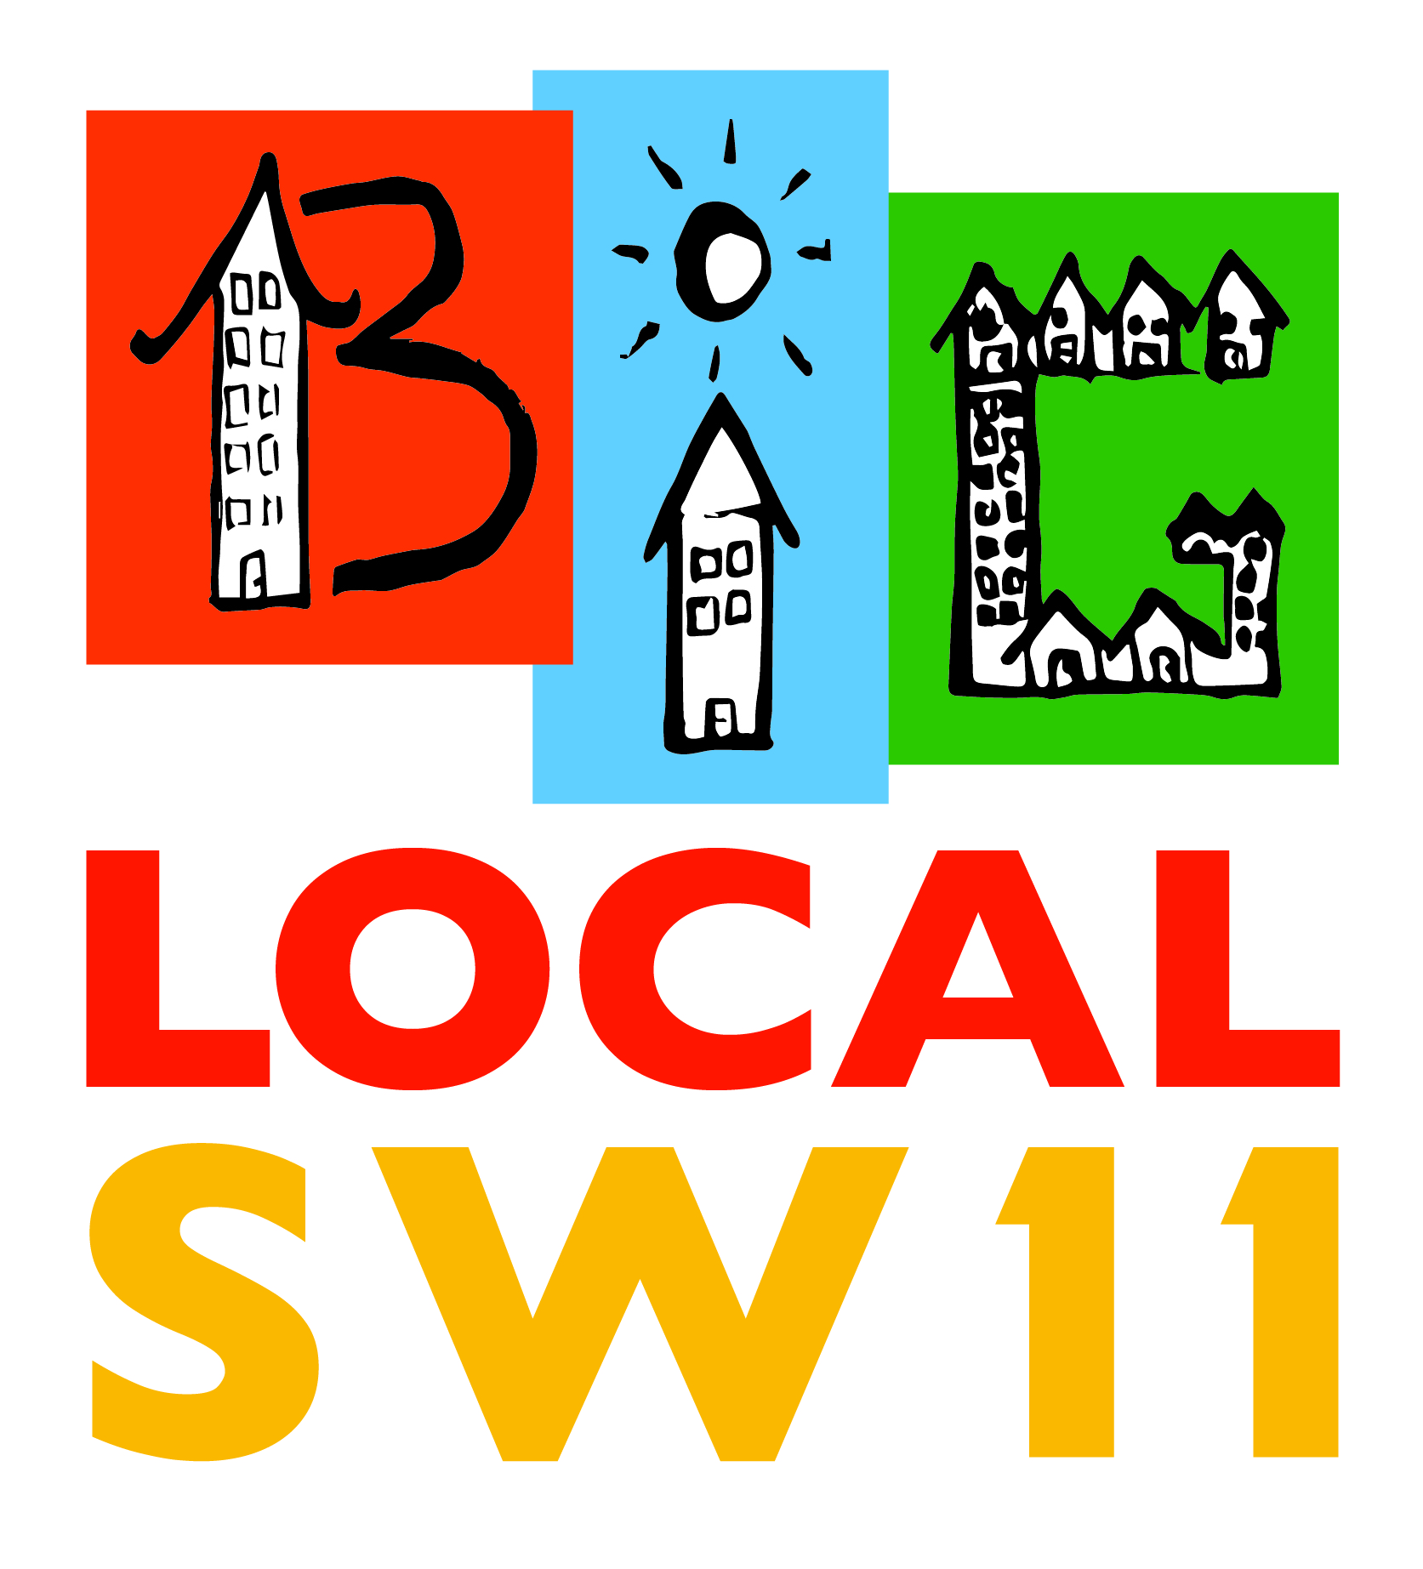
Festival Feedback Form

Completing this brief feedback form will greatly assist in helping us to plan for next year’s Festival!
Your contact details:
Name: ____________________________________
Organisation: ____________________________________
Address: ____________________________________
Email: ____________________________________

- How would you rate the Festival from 1 to 5

1= Very Poor; 2 = Poor; 3. = Not Sure 4 = Good; 5 = Excellent

2. What did you like about the Festival? _________________

3. What did you dislike? _______________________________________

4. What would you like to see next year? _________________________

5. Do you want to be involved in planning for next year’s Festival? Y/N
6. Do you want to participate on the day of the Festival next year? Y/N
7. Do you want to be kept informed of other Big Local SW11 initiatives? Y/N

Thank you from the Big Local SW11 Partnership!

Please complete and return the following to me at stonedavi@gmail.com

